

***OPEN CONTRACTING DIGITAL PROCUREMENT SYSTEM***

*Technical Concept Paper*

December 2020

Table of Contents

Table of Contents 2

List of tables 3

List of figures 3

List of abbreviations 4

Executive Summary 1

1 Objectives 4

2 Open Contracting Digital Procurement System concept 5

2.1 Alignment with EU best practices 8

3 eProcurement reform technical concept 10

3.1 General introduction 10

3.2 Regulatory reform axis 10

3.3 Business: Key strategic decisions 14

3.3.1 Strategic decision 1: Single vs. multiple platforms 14

3.3.2 Strategic decision 2: Coverage 16

3.3.3 Strategic decision 3: Integration 22

3.3.4 Strategic decision 4: Management 24

3.3.5 Strategic decision 5: Acquisition 24

3.3.6 Strategic decision 6: Development 27

3.4 Technology reform axis 28

3.4.1 Architecture 30

3.4.2 End-user technology 32

3.4.3 Interoperability 32

3.4.4 Security 33

3.4.5 Technology choice 33

3.4.6 Infrastructure 35

3.5 System implementation budget 36

3.5.1 Fee model 36

3.5.2 Setup and operational costs 37

3.5.3 Maintenance costs 38

3.6 Implementation plan approach 38

3.6.1 Implementation Phase I 39

3.6.2 Implementation Phase II 41

3.7 Challenges to be addressed 41

4 Next steps for eProcurement reform implementation 45

5 Annexes 46

5.1 Annex I - Functionalities description 46

5.2 Annex II - Case study: Moldova MTender implementation 47

**Error! Hyperlink reference not valid.Error! Hyperlink reference not valid.Error! Hyperlink reference not valid.Error! Hyperlink reference not valid.Error! Hyperlink reference not valid.Error! Hyperlink reference not valid.Error! Hyperlink reference not valid.Error! Hyperlink reference not valid.Error! Hyperlink reference not valid.Error! Hyperlink reference not valid.Error! Hyperlink reference not valid.Error! Hyperlink reference not valid.Error! Hyperlink reference not valid.Error! Hyperlink reference not valid.Error! Hyperlink reference not valid.Error! Hyperlink reference not valid.Error! Hyperlink reference not valid.Error! Hyperlink reference not valid.Error! Hyperlink reference not valid.Error! Hyperlink reference not valid.Error! Hyperlink reference not valid.Error! Hyperlink reference not valid.Error! Hyperlink reference not valid.Error! Hyperlink reference not valid.Error! Hyperlink reference not valid.Error! Hyperlink reference not valid.Error! Hyperlink reference not valid.Error! Hyperlink reference not valid.Error! Hyperlink reference not valid.Error! Hyperlink reference not valid.Error! Hyperlink reference not valid.Error! Hyperlink reference not valid.Error! Hyperlink reference not valid.Error! Hyperlink reference not valid.**

List of tables

Table 1 Review against EU best practices 8

Table 2 Common single users identified and their roles in the public procurement lifecycle 22

Table 3 Open Contracting Digital Procurement System Technology choice 34

Table 4 Fee model estimation 37

Table 5 Challenges of the implementation of an eProcurement system 42

Table 6 Functionalities description 46

List of figures

Figure 1. Model of MTender Networking Digital Procurement System (pilot partners as of September 2019) 5

Figure 2. MTender coverage of the public procurement lifecycle 5

Figure 3. MTender project milestones 5

Figure 4. MTender project legal amendments needed 5

Figure 5. MTender key results (September 2019) 5

Figure 6. MTender participation figures 5

Figure 7. MTender public procurement stage 5

Figure 8. Main pillars of OCDPS 5

Figure 9. Main characteristics of the system 7

Figure 10. Public procurement regulation schema 14

Figure 11. Comparison of single platform model vs. open networking model 15

Figure 12. Public procurement lifecycle 17

Figure 13. TO-BE functionalities map of the eProcurement system 21

Figure 14. Acquisition process for an eProcurement Central Unit 25

Figure 15. Accreditation process for NEPPs 27

Figure 16. Goals of proposed data tools 30

Figure 17. High-level architecture 31

Figure 18. Implementation plan Phase I 41

List of abbreviations

|  |  |
| --- | --- |
| AA | Association Agreement |
| BPMN | Business Process Model and Notation |
| CA | Contracting Authority |
| CPV | Common Procurement Vocabulary |
| EBRD | European Bank for Reconstruction and Development |
| ECAS | European Commission Authentication Service |
| EO | Economic Operator |
| eProcurement | Electronic Procurement |
| e-PS | Electronic Procurement System |
| ESPD | European Single Procurement Document |
| EU | European Union |
| EUPD | European Union Procurement Directives |
| GPA | Government Procurement Agreement |
| NEPPs | Networking Electronic Procurement Platforms |
| NGO | Non-Governmental Organisation |
| OCDS | Open Contracting Data Standard |
| OCDPS | Open Contracting Digital Procurement System |
| OJEU | Official Journal of the European Union |
| PP | Public Procurement |
| PPL | Public Procurement Law |
| RM | Republic of Moldova |
| SLA | Service Level Agreement |
| TED | Tenders Electronic Daily |
| UAH | Ukrainian Hryvnia |
| WTO | World Trade Organization |

# Executive Summary

This **technical concept paper** summarises the vision for **digital transformation of public procurement**, detailing the main characteristics and considerations for **implementation of collaborative shared services for digital procurement, based on Open Government principles and use of open source technologies and open data in the format of the Open Contracting Data Standard (OCDS)**.

The digital procurement model meets **most of the recommendations and best practices identified** in existing policy-making documents and comparative practice in the European Union and other **international standards**, and has already been highlighted as a **good practice on a global basis**[1]. It also guarantees **compliance with international legal frameworks** such as the UNCITRAL Model Law and the European Union Directives on Public Procurement, and is aligned with the World Trade Organization Government Procurement Agreement (GPA).

The Open Contracting Digital Procurement System allows (OCDPS) concept is based on the **knowledge acquired through the implementation of the OCDPS** in other jurisdictions (such as Ukraine or Moldova). Additional information on the system is provided in section 4.

The Open Contracting Digital Procurement System allows for a **leapfrogging transition directly to full adoption of electronic procurement** . This means transitioning from purely paper-based public procurement processes to end-to-end digital procurement. It should be stressed that the **solution is suitable for countries that are already implementing eProcurement solutions,** which cover certain parts of the procedure but are not fully mature.

The design of the **OCDPS** is based on a **modular approach** using Business Process Model and Notation (BPMN) representation of procurement processes and the underlying workflows, which enable:

* The **self-executability of regulatory requirements**; **flexibility** in terms of the use of libraries of technical specifications and terms and conditions (and, potentially, of award criteria and evaluation methods);
* **Modularity** in terms of the potential automation in the context of diverging levels of eGovernment development, which could achieve high levels of sequential, cumulative checks throughout the procurement process;
* High levels of **data resilience**; and modularity in terms of **information management** and **publication,** and **role based permissions** of the system.

Building on the above policy and business concepts, the OCDPS proposes a cutting-edge digital procurement service that supports ‘end-to-end’ public procurement processes, from planning to payment for public contracts. The proposed digital solution is a **multi-platform networking procurement system in a distributed blockchain-like architecture.** Digital procurement services are delivered to end-users (buyers and seller) by eProcurement commercial platforms, called Networking Electronic Procurement Platforms (NEPPs), collaborating with a government-owned central database unit. The solution comprises a government-operated ‘single window’ web portal, the OCDS central data exchange unit, and several commercial electronic platforms that network with the web portal and the OCDS data exchange unit.

The EBRD UNCITRAL Initiative approach to digitalisation of public procurement builds upon **six main business concepts** that aim to ensure not only the sustainability of reforms, but also prioritise a model that ensures a transparent and efficient digitalisation of public procurement function in the government. These concepts are:

* **end-to-end electronic public procurement** in order to provide a global vision of the process as well as increase the transparency and efficiency of procurement;
* **sustainable digital government service** based on commercial user fees for digital procurement services, with minimum funding required from state budgets;
* **multi-platform networking model** based on a collaborative delivery scheme that optimises digital service accessibility and quality to end users;
* **open source, open data, Open Contracting Data Standard,** in order to prevent a lock-in effect for governments and provide higher transparency and accountability by incorporating open data standards;
* **high level interoperability** in order to allow the reuse of e-government and e-commerce services and provide full coverage of the procurement process;
* **cost and time efficient implementation** through a) a high-level standardisation of procurement processes; b) a modular design of electronic workflows; and c) the re-use of existing OCDS-based tools and services.

The key reform decisions **are explained from legal, business and technology perspectives** and aim to facilitate governance models for public procurement that deliver:

* **public procurement policy** that is user and performance driven;
* **regulatory frameworks** that are based on recognised international legal standards for public procurement but engineered for stakeholder feedback and open to collaboration with the business community, including small and women led businesses;
* **innovative digital government solutions** that are creating online marketplaces for public and private sector alike.

From the **legal perspective**, it is recommended to build **a principle-based and technology neutral primary law** that is compliant with international standards and regulates technical details through secondary law. It is also encouraged **to use the Guide to Enactment [2] proposed by the 2011 UNCITRAL Model Law on Public Procurement**, combining the different modules in order to adapt to the characteristics of each country market.

The **EBRD guide for eProcurement reform**[3] outlines six main **business decisions** to be taken when designing a new, or redesigning an existing, eProcurement system. The following are the recommendations to implement the concept proposed:

Table 1 Recommendations for implementing the concept

|  |  |
| --- | --- |
| **Single vs. multiple platforms** | The system shall be an **open networking model.** |
| **Coverage** | The eProcurement scheme shall offer **end-to-end coverage of the entire public procurement cycle**, including pre-tendering and post-tendering, as well as **all public procurement procedures**. Upon this strategic goal, tactical and operative decisions that enable a smooth and scalable uptake of eProcurement should be taken. |
| **Integration** | The system shall be **integrated with the current strategy for e-government services** and aligned with the European strategy regarding the digital agenda. To that end, the system shall be fully **integrated with available e-government services and shall exchange information with other relevant state registers** dealing with the procurement process (such as justice or economic related registers). It can also be integrated with eSender, in order to exchange information with TED[4] (if necessary). |
| **Management** | There should be a **cooperative management of the eProcurement system**, mainly dividing the functions between the different relevant stakeholders (Regulatory Authority, eProcurement Manager, review body, etc.) |
| **Acquisition** | The **Central Unit should be developed using available OCDS-based open source solutions** developed under technical support projects sponsored by international donors (World Bank, ADB or EBRD). Additionally, for the front-end platforms (NEPPs), **a process of NEPPs accreditation will have to be carried out**, to ensure that they offer standardised processes and comply with legal requirements. |
| **Development** | The implementation strategy shall contemplate a **gradual implementation of electronic procedures**, based on the existing open source solution. It shall ensure a smooth transition to full coverage of electronic procedures by implementing some procedures as a pilot in the first stage. |

Regarding **technology**, there are several issues that shall be considered, especially when drafting the business and technical specifications of the system:

Table 2 Technology selection

|  |  |
| --- | --- |
| **Architecture** | The system consists of distributed architecture with 1) a government-run central unit that serves as the business processes orchestrator, and as the online OCDS data exchange and repository; and 2) networking commercial electronic procurement platforms that provide digital procurement services to contracting authorities and economic operators. All information is synchronised in real-time in all involved platforms. |
| **End-user technology** | A requirement must be in place to ensure that the system is compatible with all usual browsers and other software and does not require the user to purchase additional software. |
| **Interoperability** | The system shall be interoperable with other government services, when available and if feasible. From a data point of view, interoperability is ensured with the use of open source programming and the Open Contracting Data Standard. |
| **Security** | Security requirements must ensure that all users are known and correctly identified, and that the most sensitive documents and transactions (such as bids) are kept encrypted until they are needed. |
| **Technological choice** | The use of open source solutions and technologies should be at the core of the system implementation. The benefits of open source are higher quality, better reliability, greater flexibility, lower cost due to the avoidance of costly software licenses, and an end to predatory vendor lock-in. |
| **Infrastructure** | It shall be ensured that there is enough telecommunications capability to allow replicating the procurement data in almost real-time between platforms. |

The Open Contracting Digital Procurement System is a **self-sustaining solution** operated with **low government funding**. It is based on **a fee model** that **covers the costs of development and maintenance of the OCDS Central Unit** and the operating costs of the Networking Electronic Procurement Platforms.

It is recommended to divide the system implementation into **phases**. The first phase should start with a **pilot on micro and low value procurements,** followed by a **pilot on high value procurements** (above the EU/GPA thresholds), as best practices suggest.

In order to guarantee the success of the eProcurement system implementation, there are some challenges that need further consideration. The main issues that the eProcurement reform might face concern the **availability of providers for the eProcurement system,** the **non-reuse of available EBRD solutions,** and the **lack of political support,** which should be addressed through the different mechanisms defined in this document.

# Objectives

The goals of this document are to:

Table 3 Document goals

|  |  |
| --- | --- |
| **1** | **Propose an Open Contracting Digital Procurement System concept** that satisfies international standards on eProcurement and can be adapted to each country’s reality. |
| **2** | **Present the key issues to discuss when facing an eProcurement reform** in a country. |
| **3** | **Discuss EBRD recommendations on each of the key issues identified** and on implementation matters, based on previous experiences in other countries. |







# Open Contracting Digital Procurement System concept

The Open Contracting Digital Procurement System (OCDPS) concept has been designed with six key pillars in mind:

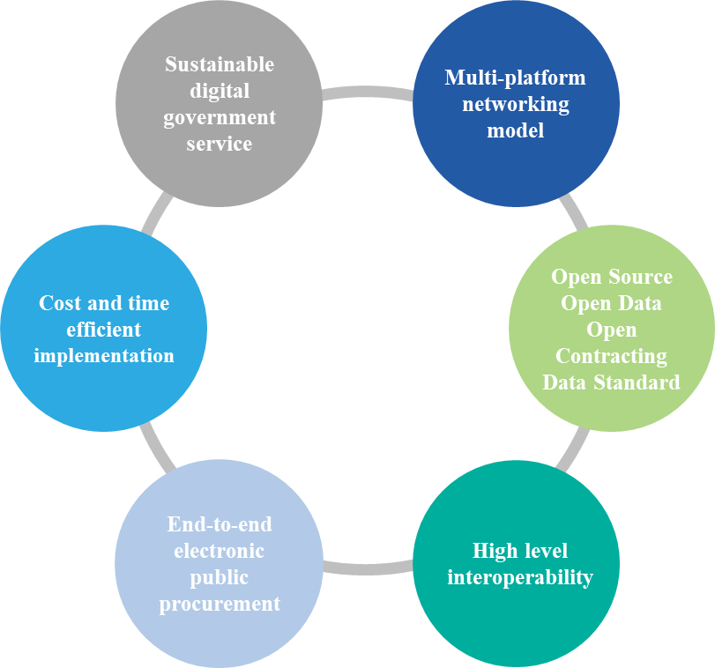

Figure 8. Main pillars of OCDPS

* **Cost and time efficient implementation**: The eProcurement scheme seeks cost and time efficiencies through a) a high-level standardisation of procurement process; b) the modular design of electronic workflows; and c) the re-use of existing OCDS-based tools and services to offer data analytics and market intelligence functionalities, drawing on data from fully digitalised public procurement processes.
* **Multi-platform networking model**: The eProcurement scheme combines e-government services operated by the government with services of commercial electronic platform operators, in order to create a collaborative delivery scheme that optimises digital service accessibility and quality to end users among public sector buyers and private sector economic operators, service providers and contractors. The eProcurement scheme is open to new Networking Electronic Procurement Platforms (NEPPs) operators, to encourage innovation by new entrants and maintain a high quality of service for end users.
* **Sustainable digital government service:** TheeProcurement scheme is fully funded from economic operator fees for digital procurement services; no initial funding from state budgets and no later exposure of state budgets is envisaged. No fees are charged to contracting authorities using the system.
* **Open source, open data, open contracting data standard**: To allow the government to prevent the lock-in effect, only open source applications are used in the system, strengthened for higher transparency and accountability by incorporating the Open Contracting Data Standard[5].
* **End-to-end electronic public procurement:** The eProcurement scheme covers the entire public procurement process, from planning to invoicing and payments under public contracts, to increase the transparency and efficiency of procurement.
* **High level interoperability**: eProcurement system applications are designed for interoperability with existing and future e-government and e-commerce services.

**The Open Contracting Digital Procurement System** offers an end-to-end electronic procurement management system with three main characteristics:

* The design of the system is based on a **modular approach to the BPMN representation of the procurement processes** and the underlying workflows, which enable the self-executability of legal mandatory requirements; flexibility in terms of the use of libraries of technical specifications and terms and conditions (and, potentially, of award criteria and evaluation methods); modularity in terms of the potential automation in contexts of diverging levels of e-government development, which could achieve high-levels of sequential, cumulative checks throughout the procurement process; high levels of data resilience; and modularity in terms of information management and publication, and permissions of the system.
* The system is built on a **networked interoperable digital procurement architecture** that relies on the interaction between the single point of access web portal, the data exchange central database unit, and a variable number of networking electronic procurement platforms. The interconnection between the central database and commercial marketplaces is facilitated by an Application Programming Interface (API) that exchanges data electronically and automatically. As a result of the interoperability between the single point of access web portal, the central database and the NEPPs, a collective authentication, synchronisation and validation of the data is achieved in almost real time for all transactions conducted on the system (which could characterise the system as ‘blockchain-like’). The central database itself is designed in a modular way, so that it can either solely ensure data exchange, or also operate as a process manager (i.e. smart database).
* The system is designed to facilitate the **automated generation and publication of open procurement data** in OCDS format and in real time. This results in a data architecture that ensures that clean and rich open procurement data is available for immediate and broad re-use, without the need for data extraction or further processing. This avoids the negative effects of data manipulation by creating a common source of objective and clean data that is automatically generated and available to all stakeholders – that is, government, businesses and civil society. This also ensures a high level of data resilience of the electronic procurement system. This data architecture provides the foundation for the open data analytics solution. The system is implemented based on open access technologies, which **avoids future risks of lock-in with a specific solution or provider.**

The result of this design choice is a self-executable BPMN engine that offers the additional feature of ensuring a much higher level of accuracy in reflecting the regulation of the procurement process than non-electronic procurement management approaches.

**The main characteristics of the Open Contracting Digital Procurement System** are summarised as follows:

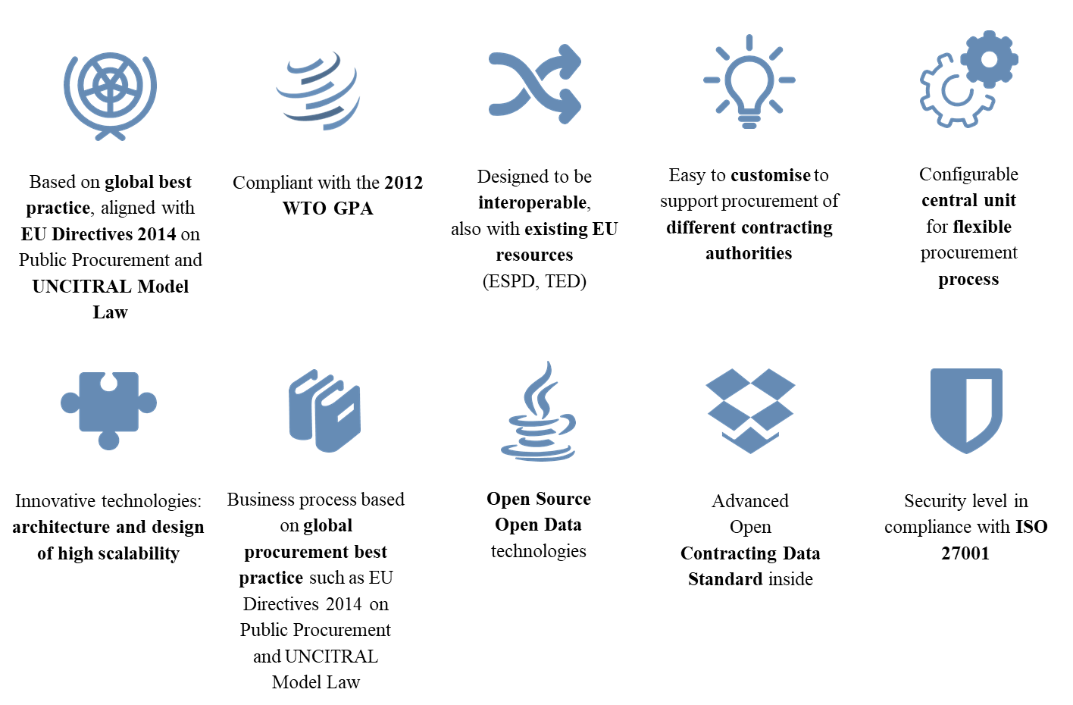

Figure 9. Main characteristics of the system

Additionally, some positive externalities can be generated under this model, which:

* Increases cross-border competition for the provision of commercial marketplace services and eProcurement platforms, as well as the emergence of value-added services such as tender preparation support, commercial information, consultancy or legal advice, etc.;
* Incentivises the emergence of more developments and/or a community of developers;
* Facilitates cross-border cooperation, for example, in the context of the European Union and its initiatives on eProcurement, which could more easily overcome some of the difficulties encountered in closed procurement systems;
* Generates a network or community of jurisdictions having implemented the same solution.

The open source code for the **Open Contracting Digital Procurement System** is provided in the following GitHub: <https://github.com/MTendereProcurementSystem/MTender/wiki>

## Alignment with EU best practices

The **Open Contracting Digital Procurement System** has been mapped against the European Union Best practices on eProcurement, specifically the e-Procurement Golden Book of Good Practice[6] and recommendations by the e-Tendering Expert Group (e-TEG)[7] of the European Commission.

Table 5 Review against EU best practices

| **Criterion / best practice** | **Golden Book** | **e-TEG OR** | **Open Contracting Digital Procurement System** |
| --- | --- | --- | --- |
| * Platforms automatically transmit all their notices to a single point of access for publication | 1 | 3.1 | Yes |
| * Affordable training plans for economic operators and contracting authorities | 2 | 2.2 | Yes |
| * Platforms have communication plans to promote the use of e-Procurement | 3 | - | Yes |
| * Economic operators can access and retrieve contract notices and tender specifications as anonymous users from a single window web portal | 4 | 1.1 | Yes[8] |
| * Economic operators can register on a platform without having to provide country-specific information | 5 | 1.1 | Yes |
| * Economic operators complete/validate their registration on a platform by clicking an activation link sent by email | 6 | 1.1 | Yes |
| * Platforms support English in addition to the official language(s) | 7 | 12.1 | Yes |
| * Economic operators can log in to platform with username and password | 8 | 1.1 | Yes |
| * Economic operators can search contract notices using search criteria | 9 | 3.1 | Yes |
| * Economic operators can evaluate whether tender specifications are relevant for them based on information available in contract notices | 10 | 3.1 | Yes[9] |
| * Economic operators are notified of changes to tender specifications | 11 | 3.1 | Yes |
| * Platforms support automatic transmission of all types of notices to TED | 12 | 3.1 | Yes |
| * Economic operators and contracting authorities can search CPV categories based on their code or their description | 13 | - | Yes |
| * Contracting authorities can re-use information in their profile or previous notices to create contract notices, tender specifications and award notices | 14 | 2.1 | Yes[10] |
| * Economic operators can choose to manually or electronically sign a submission report containing the hash value of each submitted document | 15 | 6.8 | Partially |
| * Economic operators receive proof of delivery upon successful tender submission | 16 | 6.4 | Yes |
| * Economic operators can re-submit tenders up until the submission deadline | 17 | 6.3 | Yes |
| * Platforms keep tenders encrypted until the opening session | 18 | 6.7 | Partially |
| * Contracting authorities can evaluate part of their tenders automatically based on pre-defined criteria | 19 | 2.3, 9.2 | Yes |
| * Platforms use European e-Signature validation services during e-Submission | 20 | 6.8 | Not required in current implementations |
| * Platforms clearly indicate all costs related to use of the platform | 21 | - | Yes |
| * Economic operators can create tenders using a core set of structured data and unstructured documents | 22 | 6.2 | Yes |
| * Economic operators have freedom to choose the platform of their preference without being locked in by the choice of contracting authority | 23 | - | Yes |
| * Platforms use standard specifications to structure data and promote interoperability | 24 | - | Yes |

# eProcurement reform technical concept

## General introduction

eProcurement reform is a **holistic reform** that impacts several aspects of the public procurement system of a country. Following the **guidelines set by the EBRD**[11], the current technical concept organises the description of the eProcurement reform into three areas of work: **legal, business and technology**. For each of them, a description is provided of what should be reformed and why. For every decision taken, there is a recommendation aligned with the implementation of the Open Contracting Digital Procurement System concept described in the previous chapter and based on previous work conducted by the EBRD and on international best practices and standards.

## Regulatory reform axis

The public procurement process (from planning to tender to award and throughout public contract implementation) should be **simple, accessible and inclusive**. Public procurement policy should promote **sound governance, competition and sustainable development goals**. Public procurement regulation should aim to **secure transparency, accountability and integrity of procurement decisions and maximise participation of the business community in public tenders**, since level of competition is a recognised driver of value for money in public spending. Regulations should be clear and easy to follow for numerous procurement officers in all levels of government, who may not possess legal training and should not, to the greatest extent possible, be exposed to different or conflicting interpretations of procurement rules.

The procurement process is not an end but serves for the delivery of public services and should be designed to drive fiscal performance in government and result in quality public services for citizens. Regulatory reforms should strive to support making public procurement legal frameworks compliant with international policy standards, while they are also optimised for the digital economy.

*‘Principle-based’* and *‘technology neutral’* public procurement laws

The 2011 UNCITRAL Model Law on Public Procurement recognises challenges for legislators brought by technological progress and introduced an idea of ‘**principle-based’** and ‘**technology neutral**’ primary public procurement law. In accordance with these concepts, primary public procurement laws should prescribe principles to be followed in public procurement, introduce key economic concepts of public procurement, and general rules of procurement procedures. **Transparency safeguards, value for money through fair competition, and fiscal efficiency of procurement** for governments are key procurement principles promoted by the 2011 UNCITRAL Model Law. At the same time, primary laws should avoid prescribing formats of procurement proceedings or define the technology to be used - technical details potentially prone to be quickly outdated can be introduced in the secondary legislation on public procurement. Secondary legislation with technical requirements for procurement procedures and specific guidance on the technological requirements can be revised more easily, to enable national legislators and policy makers to match technological progress or market developments, and do not jeopardise the efficiency of procurement by lengthy processes of amending primary laws.

*‘Policy tool-box’* for governments

The 2011 UNCITRAL Model Law on Public Procurement collected the latest global best practices on public procurement to inform national lawmakers. The 2011 text provides a standardised description of procurement best practices and describes various procurement methods and techniques that may be needed by governments for different types and values of public procurement contracts. The UNCITRAL Model Law describes various available practices and methodologies for each stage of the public procurement process (advertising, solicitation, evaluation, award and contract implementation) that can be selected, based on procurement characteristics and combined to create a suitable procurement method. This standardisation of procedural steps and setting the rules for their combination into procurement methods facilitates flexibility of procurement regulation but maintains certainty for procurement officers and predictably of the procurement process for participating economic operators.

The features of the 2011 UNCITRAL Model Law greatly facilitate digitalisation. Modularity in the regulatory approach to procurement methods is very efficient, as it allows providing several different electronic procurement procedures on the eProcurement platform using modern process engine technologies, Lego-style building blocks of standardised procurement steps expressed as digital workflows, and a set of relevant business rules sequencing these steps into the procurement process.

At the same time, the modularity of the UNCITRAL regulatory framework allows the selection and set-up of procedural options that comply with the mandatory policy standards of the World Trade Organization (GPA) and/or the European Union directives on public procurement. This way, electronic procurement procedures based on the UNCITRAL Model Law can be developed to be compliant with various procurement policy standards (the EU or WTO), while being deliberately geared towards minimising corruption and collusion risks and increasing value for money and the fiscal efficiency of procurement for governments, as strongly promoted by the 2011 UNCITRAL Model Law on Public Procurement.

To that end, transparency safeguards are listed in the enumerative manner and can be expressed in datasets to be published online as the OCDS open data. Using OCDS, the standardised steps of the public procurement process are easy to map for creating digital procurement workflows.

***Implementation considerations***

The most effective way to approach these legal considerations when pursuing digitalisation of public procurement is to recognise that domestic public procurement markets vary, and the different market segments should be regulated in different ways in order to avoid creating additional barriers to entry. To address the problem in practice, it is proposed to start the implementation of the eProcurement through a bottom-up approach, introducing eProcurement first to the lowest-value public contracts (micro procurement). Starting digitalisation of public procurement from micro procurement allows for the testing of local capacities in various eProcurement techniques. Such testing of new eProcurement regulations, new digital tools and new operational practices is conducted in a low-risk environment (low value procurement).

Through several initiatives[12], the EBRD has developed a set of public-sector oriented analytics tools that have resulted in a methodology intended to eliminate corruption and ensure compliance with laws and regulations. It facilitates online, real time monitoring of electronic procurement procedures, and an automated system to ‘red flag’ irregularities for further investigation. The Open Contracting Digital Procurement System can be implemented alongside these tools, which would facilitate the monitoring and accountability of public spending. These systems would allow for the deployment of Robotic Process Automation (RPA) to check specific compliance issues, such as rules preventing the artificial split of contracts. Under some circumstances, the developed analytics also offer quite sophisticated competition and collusion screens. It is also possible to use the indicators and the aggregated information generated by the system to cross them with other sources of external/own data (e.g. lists of tax avoiders or a database including results of inspections by any relevant authority), in order to create additional customised screens to support the decision-making and enforcement activities of other entities to which procurement is a relevant activity.

Public procurement laws do not typically detail rules and provisions regarding micro procurement; usually, only the broad principles of procurement law apply. Therefore, optimisation of this procurement process for digital environment can be experimental and very innovative. When electronic bidding in micro procurement is well established, lessons learned from their digitalisation can be applied to the next part of the public procurement market – low value contracts that are not of interest to international trade (too low for cross-border bidding), but of huge importance to domestic economic operators. More eProcurement tools can be brought forward, because both contracting authorities and economic operators have already gained some confidence in using digital tools for public procurement. When majority of end users on the market are familiar with tools and practices, the most complex procurement methods for high-value contracts can be more easily digitalised, because their implementation will build on both regulatory and technology experience gained in previous stages of the digitalisation process.

|  |
| --- |
| **Recommendation** |
| 1. **Implement the following law structure** |
| 1. **Implement eProcurement legislation with a bottom-up approach**   As previously mentioned , the best way to start the implementation of eProcurement is through a bottom-up approach, introducing eProcurement first for the lowest-value public contracts (micro procurement), since this allows for the testing of new regulations, digital tools and operational practices in a low-risk environment (low value procurement). Later on, procurement methods for low-value and high-value contracts can be easily added, since implementation will build on both regulatory and technology experience already gained in previous stages of the digitalisation process. |

Figure 10. Public procurement regulation schema

## Business: Key strategic decisions

There are several **critical business decisions** that impact the manner in which public procurement services are provided. The outcome of these decisions will guide not only how the eProcurement system is acquired, developed and maintained but also how public procurement is conducted on a daily basis by public procurement officials.

The following business decisions need to be taken regarding the implementation of a model for digital procurement:

1. Single vs. multiple platforms
2. Coverage
3. Integration
4. Management
5. Acquisition
6. Development

### Strategic decision 1: Single vs. multiple platforms

The platform model discussion is based on the existence of **two different eProcurement models**. The first one is the **single platform model**, in which only one platform serves all CAs and EOs involved in public procurement processes. The second model, the **multi-platform model**, is based on **an eProcurement framework that establishes standards and requirements that enable several private platforms to provide eProcurement solutions**. In this model, both the CAs and the EOs can choose from multiple platforms to conduct the same procedure.

Based on a review of experiences of both types of platforms, it is recommended to use a variation of multiple platforms called the open networking model. The open networking model allows both contracting authorities as well as economic operators to choose a platform to use without long-term contractual commitment, since all public procurement information can be accessed from every platform due to the existence of the OCDS Central Unit that synchronises the data across the network. Similarly, economic operators can submit their bids or participate in auctions from any platform, regardless of the platform where the tender was originally published.

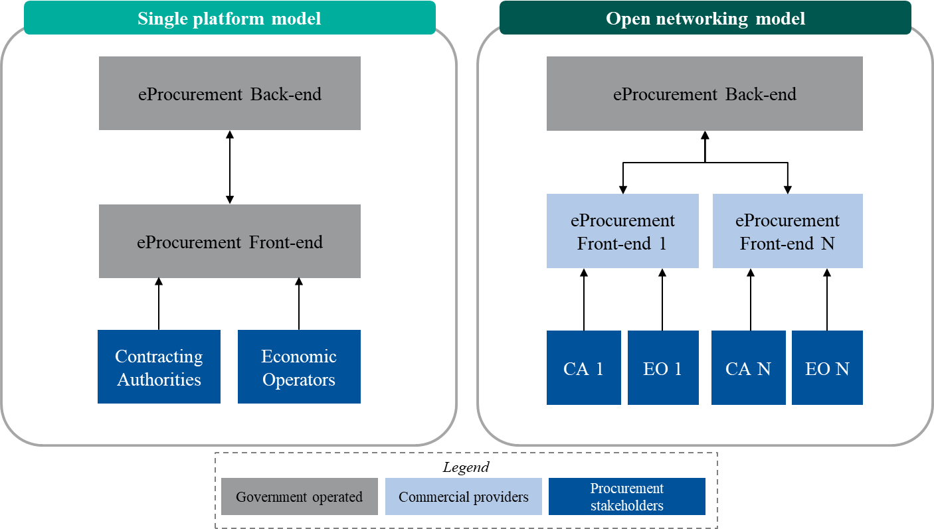

Figure 11. Comparison of single platform model vs. open networking model

Key benefits of the open networking model include:

* **Unlimited capacity in terms of government infrastructure:** The government is not responsible for the whole infrastructure of the system. Government infrastructure requires little upgrading, although the number of users and the system usage increases greatly.
* **Increased participation in tenders:** NEPPs benefit from increased participation of economic operators in the tenders. Therefore, promotion and engagement activities are implemented on the NEPP side for increasing the number of bidding economic operators.
* **Support services on the NEPP side:** The model guarantees shared responsibilities regarding support services, such as helpdesk services, which are offered by the NEPPs and therefore not needed and/or supplied by the government.
* **Additional training services capacity:** NEPPs have incentives to offer a better service, such as additional training activities for users including contracting authorities and economic operators, without additional cost for the government[13].
* **Low initial costs:** As part of the development is supported by the private platforms offering eProcurement services, the government does not have to develop them.
* **Low implementation and maintenance costs**: As in the previous point, the costs are shared with the private platforms, which support part of the change management activities and are in charge of the maintenance of their own services.
* **Encourages competition between eProcurement platform providers**: Platforms compete to attract as many users as possible due to a fee structure[14] attached to this model, thereby improving the quality of the service offered.
* **Shared risk between platform suppliers**: As the model is conceived as a collective process between the government, businesses and civil society, risks are also shared, and the different actors help each other to solve issues that may arise.
* **Platform providers encourage participation of EOs in public procurement processes**: Due to the fee model, the more EOs that platform providers have, the more they earn. In that sense, participative bidding processes are naturally encouraged by NEPPs.
* **Central Unit manages and replicates all information to the multiple private platforms:** This is a great advantage of this model, as it allows everyone to have all the information, regardless of their point of access.
* **Ensures a short implementation period**: Since it is a modular system implemented within already existent private services (such as e-commerce platforms) and the reuse of existing solutions, the implementation period should be shorter than building a system from scratch.
* Access to eProcurement platforms is **free of charge for contracting authorities**: The model has been conceived to be sustained by EOs that pay fees to participate in the tenders.

|  |
| --- |
| **Recommendation** |
| * To implement an **open networking model** with a central unit that replicates in real time the information and processes contained in all the NEPPs. |

### Strategic decision 2: Coverage

In terms of coverage, the goal of eProcurement reforms is to provide **full coverage of the public procurement cycle**, including pre-tendering (ePlanning) and post-tendering (eContract Management) phases. Complete electronic coverage is necessary, not only because it **increases efficiency** but also because it **improves transparency, accountability, and traceability**. Thepublic procurement cycleis covered by the different functionalities implemented in the system, but also by integration with other e-government services and/or functionalities developed by the NEPPs.

The figure below depicts the different phases in the public procurement process:

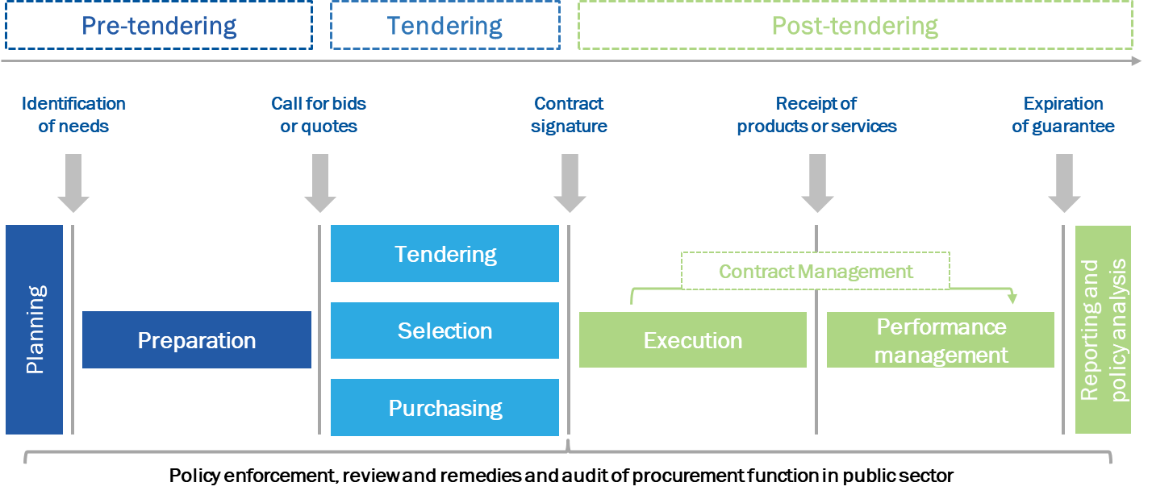

Figure 12. Public procurement lifecycle

The EBRD guide for eProcurement reform[15] recognises that, in terms of regulating the public procurement cycle, five key common functionalities of the eProcurement framework should exist: eNotice, eCommunication[16], eSubmission[17], eAccess[18], and eRecords[19]. The eProcurement solutions for the tendering process can be further supplemented by electronic solutions for the pre-tendering phase (buyer’s profile, aligning financial and procurement ePlanning) and for the post-tendering phase (eContract Management, eOrdering, eInvoicing, and ePayments).

|  |
| --- |
| BPMN 2.0 Approach  The Open Contracting Digital Procurement System is based on **BPMN 2.0 to define and implement public procurement procedures.** This allows quicker uptake of new public procurement procedures, since the system contains certain functionalities that can be reused as components to set new procedures. The BPMN approach to process description and management ensures that the digital workflows are:   1. Modular in terms of the potential integration and automation in contexts of diverging levels of available eGovernment services; 2. Flexible in terms of the use of various popular standard libraries of technical specifications, terms and conditions of contracts and framework agreements, award criteria and evaluation methodologies; and 3. Adaptable in terms of setting-up procurement cycle data management and permissions to use specific workflows of the system.   For example, to implement a restricted procedure, the open tender business process can be reused, and a qualification or pre-selection mechanism can be implemented within it, without the need to develop the whole process from scratch.  This is therefore a **modular design based on a library of sub-processes** **that can be altered to fit different approaches to the regulation of procurement procedures** and tailor them to idiosyncratic regulatory approaches in any given jurisdiction (for example, to alter the order of some of the sub-processes or to add other sub-processes), or as a result of regulatory changes.  Those sub-processes or micro-steps are then linked to the workflow of the given procurement procedure, and to the procurement data generated throughout the process, in a manner that ensures that procurement procedures carried out through the electronic procurement system are compliant with the applicable regulatory framework (subject to any system of permissioned exceptions). This modularity aims to avoid the need to modify the overall solution when there are changes in the applicable rules, which can then be implemented in relation to the specific steps affected by the reform. The result of this design choice is a self-executable BPMN engine that has the additional feature of ensuring a much higher level of accuracy in reflecting the regulation of the procurement process than non-electronic procurement management approaches.  **It should be highlighted that the use of electronic means does not add complexity, but makes the system easier for end users and generates huge benefits for public spending management.** |

The following sections discuss the two areas on which a decision about coverage must be made: 1) electronic coverage of public procurement procedures; and 2) functionalities covered in the electronic system.

#### Electronic coverage of public procurement procedures

EUPD 2014 is an internationally recognised benchmark from which to take good practice, besides being mandatory for many countries. We are adapting our model to its proposals, which ask that all procedures above the EU threshold should be electronic. Nevertheless, below EU threshold procedures shall also comply with its principles.

In general, and asprevious experiences have evidenced, **it is easier and more efficient to implement electronically the procedures for both above and below threshold**. Furthermore, if the values of the thresholds vary in the future or there are other changes to the EUPD 2014, no major changes should occur in the system regarding procedures coverage.

Moreover, the fact that procurement processes below EU threshold need to comply with the principles of EUPD 2014, means that specific public procurement secondary legislation, including regulations, standard forms, or standard bidding documents, must also be modified accordingly.

In that sense, two main EU principles – transparency and effectiveness – make a strong argument for including all procurement procedures in the eProcurement system, regardless of their position above or below EU thresholds. Moreover, direct awards should also be registered in the system in order to allow monitoring and traceability of all procurement procedures and the future aggregation of demand by services, products or any other kind.

**To summarise, the electronic coverage of all public procurement procedures is necessary, not only because it increases efficiency in the procurement process but also because it improves transparency, accountability and traceability.**

An additional issue to consider is the expected procurement volume. Knowing the main procedures and their volume helps guarantee an adjusted planning for the future eProcurement system, by being able to predict the capacity required by the new system.

|  |
| --- |
| **Recommendation** |
| * The eProcurement system should cover all **public procurement procedures**, including below threshold procedures (micro-value) normally not covered by public procurement laws. * Direct awarding shall be registered in the system for monitoring purposes. * The default public procurement procedures (open and restricted tender) shall be **fully aligned with EUPD 2014** by introducing online, standardised, declaration-based and multi-criteria selection processes. * To ensure future adaptability of eProcurement tools to new processes, public procurement procedures such as **self-executable BPMN 2.0** should be implemented, based on the existing business processes in the Open Contracting Digital Procurement System. |

#### Functionalities covered in the electronic system

This section considers the following issues: A) functionalities coverage; B) functionalities allocation; and C) single user role.

1. **Functionalities coverage**

The functionalities that are covered by the Open Contracting Digital Procurement System are depicted in the Annex: Functionalities description. The Open Contracting Digital Procurement System open source code[20] already covers such functionalities, and are available for reuse.

The precise application of each functionality can be adapted to each country’s reality and shall be further defined when discussing the concept reform and the terms of reference for the new system. Nevertheless, the following issues should be considered for the current Open Contracting Digital Procurement System:

* The **eEvaluation** functionality should allow contracting authorities to configure the evaluation criteria for lowest price and multi-criteria selections, but with an offline technical evaluation. The evaluation process can include an auction process, which is already developed under OCDS based solutions for eProcurement.
* **ePlanning and eContract Management** have not been fully implemented in the available OCDPS open source code.

The electronic coverage of the tendering phase has enormous importance in the procurement process and hence, it is the most regulated and where most efforts are placed. Nevertheless, the objective of the full electronic coverage of the public procurement lifecycle requires coverage of the pre-tendering and post-tendering phases. Implementing an electronic process in these phases allows for complete traceability of the public procurement process while increasing transparency, efficiency and data integrity.

Finally, budget and time restrictions should be considered when designing the implementation plan. Some of the above-mentioned functionalities are required by the EUPD 2014[21], but most of them can be gradually implemented.

|  |
| --- |
| **Recommendation** |
| * **The eProcurement scheme shall offer an end-to-end coverage of the entire public procurement cycle, including pre-tendering and post-tendering**. Upon this strategic goal, tactical and operative decisions that enable a smooth and scalable uptake of eProcurement should be taken. |

1. **Functionalities allocation**

Functionalities allocation analyses whether the functionalities should be kept within the Central Unit or within the NEPPs, given a predefined set of SLAs.

It has been EBRD’s experience that functionalities should be developed in the Central Unit only if one of the following criteria applies:

* **More than one user needs to be connected in real time in the same place.**
* **The government wants to be the one controlling** the transactions and the log of these transactions directly.
* **The function is used by a single user** (such as a review body). If the single user only participates partially in the system, a specific cabinet can be built for them in the back end.

According to these criteria, all functionalities that imply a direct relationship with the CA or the EO are left in the front-end. Thus the back-end only covers functionalities for single users, the eAuction module (as users need to be in the same place in real time), the ePlanning and eContract Management modules (as the government usually prefers to control the transactions on these phases), and the eMonitoring module, to manage all procurement data. The API is also included as part of the back end. The final picture of functionalities allocation would be as follows:

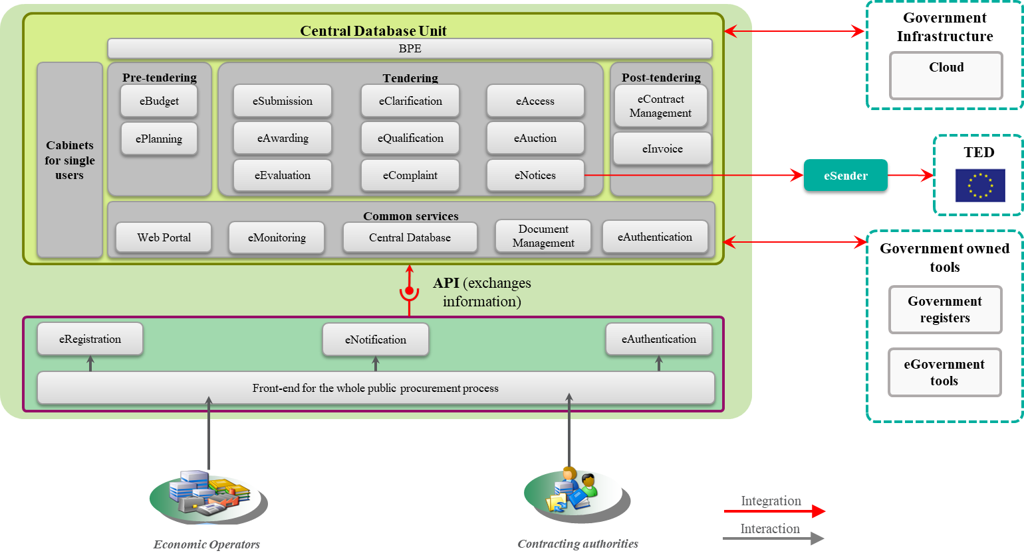

Figure 13. TO-BE functionalities map of the eProcurement system

**Integration with other existing e-government tools and EU systems (such as eSender) is discussed in the next key decision.**

|  |
| --- |
| **Recommendation** |
| * **Delegate as many services as possible to the NEPPs** in order to decrease development and maintenance costs for the government. * **Develop the logical layer in the Central Unit and implement the visual and the user-interaction layers in the NEPPs.** * **Develop ePlanning and eContract Management within the Central Unit.** |

1. **Single users’ role**

It must be considered that some “single users” may participate in the procurement process and a special feature for their needs shall be developed within the system.

Single users are typically public institutions that play a role in the public procurement process, such as validating a budget or approving an amendment, or perform any kind of ex ante or ex post control. These roles go beyond the consultation of information or data and are needed in order to advance in the public procurement process. The difference between a single user and CAs or EOs is that the single user is an agent vested with special powers and obligations that distinguish him/her from CAs and EOs but whose activity has repercussions on the functioning of the system as a whole. Therefore, implementing a specific functionality for this type of user in all the different NEPPs operating in the eProcurement framework is costly and very inefficient. An example of this type of user is a review body.

Some single users are common in most public procurement frameworks and are described below. Nevertheless, this should be adapted to each country and their potential involvement should be analysed first.

Table 6 Common single users identified and their roles in the public procurement lifecycle

| **#** | **Pre-tendering** | **Tendering** | **Post-tendering** |
| --- | --- | --- | --- |
| **Public Procurement Agency** | * Validate procurement plan (aggregation, sourcing strategy and choice of procurement method) | * Validate procurement plan (aggregation and procurement method) | * Contract signing * Validate contract amendments and extensions |
| **Complaint Settlement Agency** | * No specific role | * Ruling on complaints regarding the tender notices, tender documents or the tendering process | * No specific role |
| **State Treasury** | * Validate the procurement plan within state budget | * Validate a signed contract and its payment schedule | * Validate contract extensions * Approve and/or process payments |
| **Competition Council** | * No specific role | * Monitor compliance with competition policy | * Monitor compliance with competition policy |

|  |
| --- |
| **Recommendation** |
| * To include **cabinets within the Central Unit for the exclusive use of entities with specific roles that may need to be translated into specific workflows in the system**. * Provide **front-end interfaces for accessing single user cabinets through the Central Unit** of the system, not through NEPPs. |

### Strategic decision 3: Integration

The eProcurement framework should be integrated with the existing strategies for e-government services, when available, and aligned with the European strategy regarding the digital agenda (if applicable in the country) as a best practice in digital transformation for public services.

The EU e-government Action Plan 2016-2020 supports the transition of Member States towards full eProcurement, within a fully interoperable framework of European public administrations.

There are several levels for eProcurement integration with other systems and registers: 1) integration with other e-government services; 2) integration with government registers; and 3) integration with European and other international systems. The relevance of the integration strategy depends on whether the eProcurement system is developed at an initial stage or at a later stage of the e-government reform.

Besides the integration within the e-government strategy, an eProcurement system can also be integrated with other systems and data registers. This integration can have different goals:

* **To help reduce the corruption risks in public procurement**. The Financial Management Information Systems, for example, should be connected to the procurement modules in order to validate the contract conditions and the delivery results before making payments;
* **To improve data consistency and avoid duplication**. A link to the register of companies, for example, can help to verify the qualification data of bidders, retrieving their information automatically;
* **To save time for contracting authorities and economic operators**. A connection to relevant registers would eliminate the need for sending by post documentation or the duplicated manual input of information in several forms or registers needed for a process, and the need for EOs to visit the contracting authority’s premises.
* To have a very **complete system in terms of functionalities, reducing to a minimum the initial development** **cost**.
* To have a **long-term vision regarding eProcurement**. This means ensuring the interoperability of eProcurement systems with all relevant government services in order to perform future integrations that enable a comprehensive framework of public procurement systems that are integrated with financial and economic systems, most state registers, and other systems or services that may participate in the public procurement process.
* To ensure **a fully EU-compliant eProcurement implementation with low development costs**. That can be achieved by using tested tools, such as eInvoicing, to fulfil EU requirements when needed.

Finally, **the eProcurement system should integrate other European systems including ESPD and the procedure for sending procurement notices to TED (eSender)** [22]. The Publications Office publishes electronic notices submitted to TED within five days of their receipt. In comparison, notices sent by fax, email or post take up to 12 days to be published. This allows shortening public procurement procedures and increases efficiency in the treatment of procurement notices. Moreover, it prevents the use of the “eNotices application”, where data shall be introduced manually for publication in TED by procurement officials.

The eProcurement system should implement mechanisms that allow the automatic performance of some processes, such as evaluating ESPD compliance. This can be done by collecting data on companies from public registers and validating the ESPD against that data. To further enhance automation, RPA mechanisms can be considered.

|  |
| --- |
| **Recommendation** |
| * The **existing e-government tools should be used** within the system when possible. * Information should be exchanged with state **registers and with commercial eProcurement platform operators**. * The **automation of processes** within the procurement procedures should be fostered * **Existing tools and data should be reused** when possible. * The Central Unit should be **integrated with eSender**, if applicable, **in order to exchange information with the Tenders Electronic Daily** **(TED)**. |

### Strategic decision 4: Management

The reform needs to allocate institutional responsibility for acquisition of eProcurement services or platforms and roles in deciding upon purchasing strategies for the public procurement framework.

The main roles identified for the eProcurement management ecosystem are the following:

* **Regulatory Authority:** Body responsible for the definition of public procurement policies, standards and regulations.
* **Review Body:** Body responsible for reviewing public procurement contracts related decisions.
* **Monitoring Unit:** Unit responsible for reviewing and reporting on public procurement activity.
* **eProcurement Manager:** IT operator responsible for the maintenance and improvement of the eProcurement system.
* **Central Purchasing Units:** Units responsible for centralised purchasing for several public entities.

There are other parts of government with a more indirect interest in procurement, which seek to monitor procurement for other purposes, such as market monitoring in the context of regulated sectors, or to assess the roll-out of horizontal policies (such as green, SME-oriented or social procurement). Each of these uses might require the development of analytical tools and may rely on specific business intelligence that can require a tailoring of the eProcurement solution.

|  |
| --- |
| **Recommendation** |
| * There should be a **cooperative management** of the eProcurement system, through the assignment of specific functions to the differentrelevant stakeholders (Regulatory Authority, eProcurement Manager, review body, etc.) |

### Strategic decision 5: Acquisition

eProcurement reform requires the acquisition and implementation of an eProcurement system. To reduce acquisition costs, the EBRD recommends **re-using available OCDS-based open source solutions, such as the Open Contracting Digital Procurement System**, developed under technical support projects sponsored by international donors (World Bank, ADB and EBRD). The use of open source[23] solutions and technologies should be at the core of the system implementation. The benefits of open source are higher quality, better reliability, greater flexibility, lower cost due to the avoidance of costly software licenses, and an end to predatory vendor lock-in.

The prototypes of the OCDS digital procurement and data analysis tools are available[24] under open source licences and are deliberately designed for use with minimal IT support and low-intensity maintenance. When required, further development of the tools is intentionally a low-cost, low-skills affair. Typically, it can be done by configuration, without additional programming, to keep costs of the digital government solution low for government users.

The main recommendations related to acquisition are to first develop a Central Unit that should be government owned and operated. This ensures that sensitive information and processes are fully controlled by the government, reducing security risks.

OCDS Central Unit development

The Open Contracting Digital Procurement System Central Unit (OCDPS Central Unit) should be government owned and operated. This decision guarantees that all the sensitive processes and information regarding public procurement is fully controlled by the government and the security risks are reduced.

The Central Unit of the Open Contracting Digital Procurement System provides completely reusable functionalities and services. However, it may require adjustments and customisation to meet the specific needs and comply with the procurement regulation of each jurisdiction. Therefore, a tendering process is required in order to select the provider that would be responsible for the necessary developments, once the specifications are clearly defined.

To ensure a successful implementation of the OCDPS Central Unit, the following issues shall be considered:

* Establishing a project manager unit and a project plan for the development of the OCDPS Central Unit;
* Developing robust Invitation to Tender/detailed functional/non-functional/security specifications;
* Using a multi-criterion tendering approach, with appropriate scoring for key features;
* Including suitable references from contracts performed in the past as a key requisite;
* Ensuring the reuse of the Open Contracting Digital Procurement System as a basis for the development of the new eProcurement system;
* Ensuring post-award eContract Management and acceptance criteria;
* Integrating implementation support, training, maintenance/helpdesk and upgrade;
* Establishing that the Central Unit provider should not maintain nor establish any relationship with the NEPPs providers that may lead to a conflict of interest.

The selection process should be composed of three main phases:

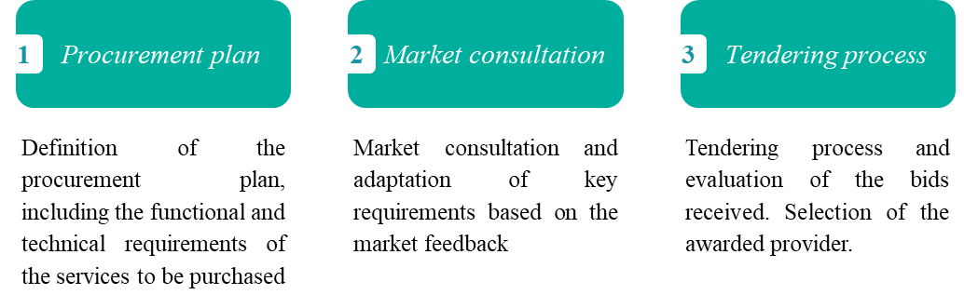

Figure 14. Acquisition process for an eProcurement Central Unit

In order to guarantee enough capacity of providers to conduct the eProcurement implementation, it is proposed to conduct a market consultation before the tendering process. Such a step provides knowledge on market availability and reinforces the functional and technical requirements defined by the contracting authority.

To define the functional and technical requirements of the eProcurement system, it must be taken into account that the implementation of the **eProcurement system should use the Open Contracting Digital Procurement System functional and technical design already defined as well as the open source developments** to reduce costs, increase efficiency and benefit from the trustworthiness of an already implemented solution. In this sense, the Open Contracting Digital Procurement System**[25]** implementation team has published all developments in open source code in order to be reused by other countries at no cost.

Additionally, to the existing Open Contracting Digital Procurement System open source code, there are other solutions that have been developed under other initiatives such as the Open Contracting Partnership (OCP)[26], which can also be reused. The tools developed by OCP are based on the use of Open Contracting Data Standard, which is the data model that is implemented following this eProcurement reform concept.

Front-end platforms implementation

The involvement of front-end platforms is based upon an accreditation process for private economic operators to get involved in the eProcurement system. This process requires the definition of Service Level Agreements, compliance clauses, and requirements that private economic operators must fulfil in order to provide eProcurement services to CAs and EOs. The Ukrainian or Moldovan accreditation processes may serve as a good practice example for selecting providers, having successfully selected several different ones[27].

It is recommended that the accreditation process goes through the following phases:

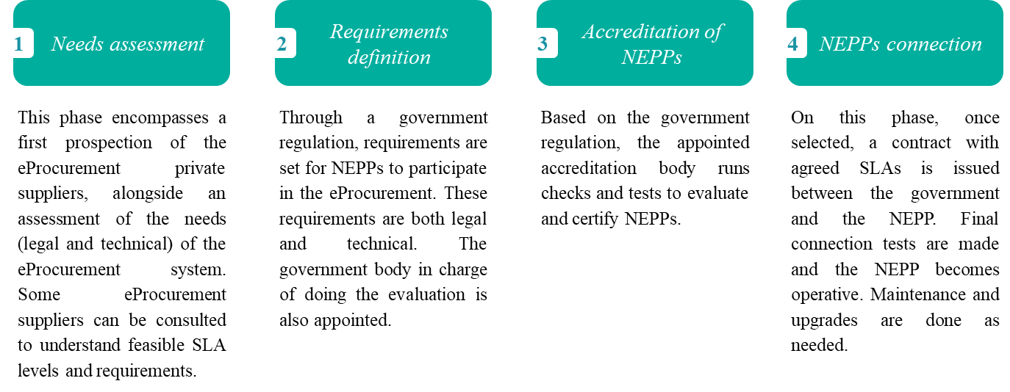

Figure 15. Accreditation process for NEPPs

The accreditation process should, at least, look at technical features and requirements, security measures and performance (through definition of SLAs). The accreditation should be time-bound and subject to a renewal mechanism, as technology evolves, and the conditions of the accredited platform may deteriorate over time.

To perform the evaluation, a government responsible should be appointed. It is proposed that the responsible body bears enough IT capacity to evaluate the different solutions. This body should be independent from the public procurement ecosystem to ensure fairness. It may also acquire independent auditing services if needed as an input to the accreditation procedure.

To define the overall accreditation process, a committee with representatives from government and the civil society may be appointed in order to ensure fairness and transparency.

Additionally, mechanisms for facilitating the management of the eProcurement system operational structure need to be in place. For example, a coordination unit between NEPPs and the Central Unit may be created. This ensures that the evolution and maintenance of the eProcurement system is smooth, and all parties are aligned and have a clear schedule of the functionalities or changes to be implemented.

|  |
| --- |
| **Recommendation** |
| * A Central Unit should be developed reusing the available open source code of the **Open Contracting Digital Procurement System solution provided by the EBRD**. The system can be further adapted through new functional and technical specification, based on the AS-IS analysis and localised reform concept. * The functional and technical specifications for the eProcurement system shall specify a scope of integrations with e-government services and the scope of adaptation of the Open Contracting Digital Procurement System open source code. The use of existing tools is intended to reduce costs and take advantage of tested technology. * **Use open source** technologies to avoid the payment of costly licenses and vendor or technology lock-in. * Other **open source tools** developed under technical support projects **sponsored by international donors** (World Bank, ADB or EBRD) should be reused when possible to reduce acquisition costs and deployment timings. * For the front-end, **a process of accreditation of NEPPs** shall be carried out, to ensure that they offer standardised processes and comply with legal requirements. |

### Strategic decision 6: Development

The development decision is based on how the eProcurement system can be significantly altered/developed to introduce new functionalities and integrated with other applications over the long term.

There are two main key points to consider:

* **Modular system**. The eProcurement system shall be built in a way that each functionality is individually developed. This characteristic guarantees that each functionality can be individually modified or upgraded without modifying the entire eProcurement system. It also facilitates the addition of new functions in later phases,
* **Integration**. One of the key elements for the development of the eProcurement system is the potential for future integration with other e-government services. The system shall not only allow the future inclusion of other modules and functionalities but should also facilitate the implementation of other procurement techniques, such as Dynamic Purchasing Systems.

In most cases a gradual implementation is necessary, and the following approach should be considered:

* Start with a **pilot in eProcurement in micro and small value procedures**, testing eAuction method and integration with e-government services, including invoicing and payments. The pilot in micro procedures presents several advantages. On one hand, as they are less regulated by the public procurement law, so it is only necessary to modify government regulations to enable electronic procedures within them. On the other hand, they represent a high aggregated value and volume that is normally outside of the system and/or control. As the main problem with this type of procedure is that it is very resource-consuming, a system that allows faster processes to launch the procurement would be more accepted by CAs and EOs.
* Additionally, undertake a **pilot of high value procedures** (above the GPA/EU thresholds), as well as testing open and restricted tenders and eSender for TED.
* Implement the new eProcurement system in at least **two phases.** In the first phase, it is foreseen that all mandatory requirements by EUPD 2014 and other best practices, including ePlanning and eContract Management, are implemented. Phase II involves the development of further functionalities or the improvement of the existing ones.
* **Contract eSignature** should be implemented first for micro and small value contracts and framework agreements and later rolled out to decentralised high value contracts. This is suggested in order to facilitate adoption of eSignature by all EOs and CAs. The process can be accelerated if the speed of take-up is faster than foreseen.

The implementation strategy is further discussed in section 4.6 Implementation plan approach.

|  |
| --- |
| **Recommendation** |
| * A **pilot implementation of electronic procedures** should be planned during the development in order to ensure a smooth transition to full coverage of electronic procedures by implementing some procedures initially as pilots. * Accordingly, the recommendation is to **implement the eProcurement system in different phases that are adaptable and can accommodate future developments**. Ensuring each new implementation is adaptable to future developments requires the system to be built through **modular solutions**. This means each functionality can be individually developed and is scalable without affecting the rest of the system and can still be interconnected with the OCDPS Central Unit. |

## Technology reform axis

Public procurement digital transformation does not aim at replicating current practices through an electronic environment. Existing paper-based procurement procedures should not be taken online, but the entire process should be redesigned as a user-friendly digital service, delivered in collaboration with the private sector. A digital service, with open data and open source tools operated by the government to secure transparency, accountability and interoperability and collaborating with commercial operators of the electronic platforms to drive competition and innovation, should become a standard for digital government services.

Therefore, all recommendations and decisions on the technological axis have in mind the need for a sound data architecture and have taken the Open Contracting Data Standards (OCDS)[28] as the basis of its data structure. OCDS helps to:

* Facilitate interoperability across budget, planning, contracting, project management and payment systems;
* Enable automated data gathering and business analytics;
* Drive analysis and use of the information; and
* Enable the building of interconnected, digital services.

Additionally, the EBRD has created OCDS-based open data analytical solutions, which can be implemented as part of the eProcurement reform. These tools offer a publicly accessible dynamic contract register, innovative business intelligence and investigative analytical solutions. They can also be used to design advanced ex ante and ex post compliance controls and risk indicators, as well as tools to support the work of national auditing institutions and collusion alerts to support the work of the national competition authorities. It is also possible to use the data architecture to design other advanced screens to support the activities of different enforcement authorities and regulators. Where data is made fully accessible on an open data and open government-oriented approach, the data can also support the engagement of civil society and the development of additional reputational tools, such as rankings of contracting authorities[29].

The existence of a clean, rich procurement data architecture allows for the development of a wide array of tools and data analytics, such as:

* Procurement market overview, using interactive visualisations and price indexes;
* In-depth micro and macro analyses, using business intelligence technologies to support strategic sourcing decisions of the government;
* Reputational tools, such as automated rankings of contracting authorities and economic operators;
* Data-driven tools for improving the enforcement of procurement policies, such as ex ante compliance monitoring, analysis of the fiscal efficiency of public procurement, or procurement performance management and auditing;
* Tools for civil society engagement in monitoring the outcomes of public procurement, which can build public trust based on the existence of one single source of procurement data for all stakeholders.

The goal of this array of tools is:

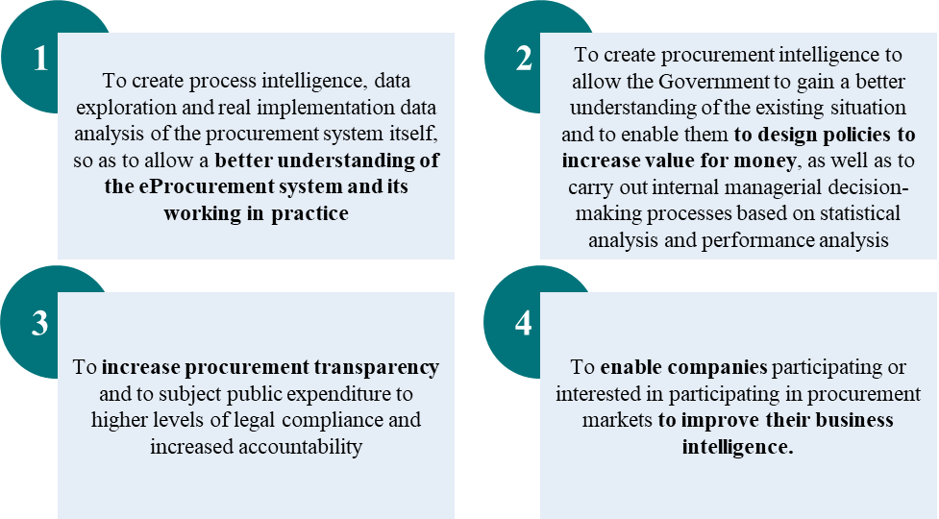

Figure 16. Goals of proposed data tools

When drafting the technical specifications for the eProcurement system there are some technological issues which need to be considered:

1. Architecture
2. End-user technology
3. Interoperability
4. Security
5. Technology choice
6. Infrastructure

### Architecture

Two of the main goals of the system are to create (i) an adequate data architecture capable of generating, recording and publishing clean procurement data, and (ii) tools that are designed for government users without advanced technical knowledge of eProcurement systems.

The digital procurement model promoted by the EBRD technical cooperation projects uses an open source and open data interoperable digital procurement architecture for multi-platform networking and works by collecting and recording all the information concerning all stages of the procurement process in a central database unit of the network.

The digital procurement systems built on this model consist of a government-run central database that serves as an online OCDS data exchange and repository for linked networking commercial electronic procurement platforms that provide digital procurement services to contracting authorities and economic operators. The information from the database is displayed on an open, accessible, searchable, government-run open source web portal. This creates a single point of access to procurement information and electronic bidding that is automatically synchronised in real time between the central unit itself, the government-run web portal, the NEPPs and other e-government services and registers (if available). The system has a networked interoperable digital procurement architecture that relies on the interaction between the single point of access web portal, the data exchange central database unit, and a variable number of networking electronic procurement platforms.

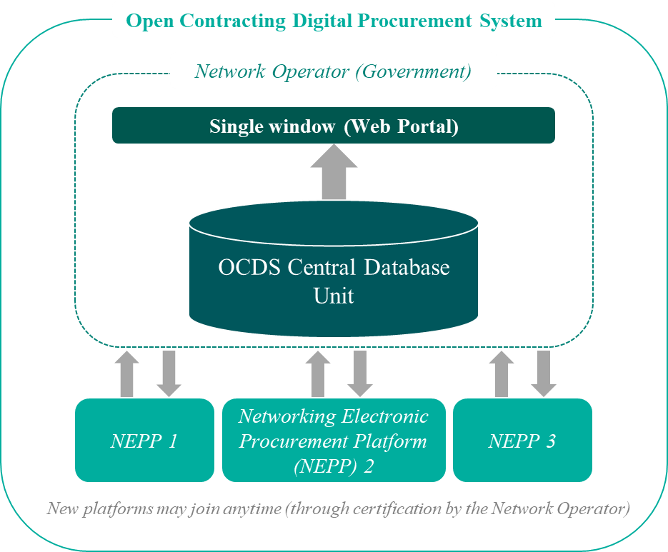

Figure 17. High-level architecture

The interconnection between the central database and NEPPs is facilitated by an Application Programming Interface (API) that exchanges data electronically and automatically. As a result of the interoperability between the single point of access web portal, the central database and the networking electronic platforms, a collective authentication, synchronisation and validation of the data is achieved in real time for all transactions conducted on the system (which could characterise the system as ‘blockchain-like’).

The central database is itself designed in a modular way, so that it can either solely ensure data exchange, or also operate as process manager (i.e. smart database). Multiple databases can be synchronised using a single front-end, which allows for implementation in decentralised or multi-tier settings. Given that the central database is designed to operate as a multi-platform interoperable system, it is underpinned by the certification of distributed electronic procurement platforms that meet functional requirements established under open source conditions.

The system can be adapted to different market structures for the provision of (de)centralised e-procurement services and to different approaches regarding the funding or cost-allocation of the system. The system is designed to facilitate the automated generation and publication of open procurement data in OCDS format and in real time. This results in a data architecture that ensures that clean and rich open procurement data is available for immediate and broad re-use, without the need for data extraction or further processing. The negative effects of data manipulation are avoided by creating a common source of objective and clean data that is automatically generated and available to all stakeholders (i.e. Government, business community and civil society). This ensures a high level of data resilience of the electronic procurement system and provides the foundation for the open data analytics solution.

By building a sophisticated and robust OCDS data architecture, the system allows for the accumulation of big data as the system is used. In turn, it can enable a wide array of big data analytics, including several different types of machine learning and AI applications (i.e. deploy machine learning to identify sources of common misunderstandings and problems to direct the issuance of guidance or, where possible, robots to implement more granular checks and balances).

|  |
| --- |
| **Recommendation** |
| * Build an Open Contracting Digital Procurement system that relies on a government-owned central unit to which multiple NEPPs connect through a single window. * Use OCDS to ensure sound data architecture. |

### End-user technology

As eProcurement systems are developed upon web based services, the adaptability of the system to the most widely used Internet tools and software packages is essential in order to prevent compatibility issues. To ensure that user technology does not prevent any EO or CA from participating in the tendering process, the system must make sure that:

* It is compatible with the latest versions of the most widely used web browsers, such as Google Chrome, Mozilla Firefox, Safari and Internet Explorer;
* It supports HTML5 standards, which are nowadays supported by the latest versions of the browsers listed above;
* It can be used with widespread, standard software such as Microsoft Office, and it does not require specific software to be purchased;
* If any additional application is needed to perform a functionality, this application should be free and downloadable by users;
* It supports multiple languages in order to display the user interface. This requirement extends to providing full support for international users, such as FAQs and online help in English.

|  |
| --- |
| **Recommendation** |
| * Ensure that end-user technology is compatible with widespread systems (Google Chrome, Mozilla Firefox, Safari and Internet Explorer, etc.). |

### Interoperability

As stated in previous sections, the system should be fully interoperable and connected to several government registers.

To guarantee this, the system is based on Open Contracting Data Standard[30], a scheme to provide shareable, reusable, machine-readable open data on public contracting across the entire cycle of public procurement. The data standard is the basis for building and sharing tools that use and analyse this information. An added advantage of this standard is that it is not proprietary, so it does not carry any additional rights or licenses.

Open Contracting Data Standard can be used not only as a publication standard but also as a transportation method for information between the different modules, functionalities and processes.

|  |
| --- |
| **Recommendation** |
| * Use OCDS to ensure data coherence and transport information between modules, functionalities and processes. |

### Security

The key issues to consider related to security are:

* Know your end users.
* Implement a Single Sign-On mechanism for end users that encompasses the NEPPs and the Central Unit. Standards, such as SAML 2.0, can be applied to fulfil this recommendation (i.e. the ECAS Single Sign-On mechanism provided by DIGIT implements a customised version of SAML 2.0).
* Consider consolidating the users into the central database unit to easily verify their existence.
* Encrypt communication channels. The recommendation is to use TLS 1.2.
* Apply the eIDAS Regulation to provide timestamp, electronic seal and digital signature so that integrity of the documents uploaded by a bidder can be guaranteed.
* Use time-bound encryption of the bids so that no one can read them before the start of the evaluation process.

|  |
| --- |
| **Recommendation** |
| * Put in place security mechanisms that ensure single sign-on and maintain tender integrity throughout the procurement process. |

### Technology choice

The system shall implement open source technologies. This reduces the overall cost of the solution due to the reduced costs of the technologies. Additionally, the system shall be based on technologies for which support is available for at least several years (minimum five) and for which evolutions and improvements are made on a regular basis.

The technology stack of the Open Contracting Digital Procurement System[31], which can be reused, is a good option for technology choice.

Table 7 Open Contracting Digital Procurement System Technology choice

| **Technology** | **Description** | |
| --- | --- | --- |
| **Spring Framework** | The Spring Framework provides a comprehensive programming and configuration model for modern Java-based enterprise applications - on any kind of deployment platform. Spring focuses on the "plumbing" of enterprise applications so that teams can focus on application-level business logic, without unnecessary ties to specific deployment environments. | https://github.com/MTendereProcurementSystem/MTender/raw/60a881c34955e0ca14eac3faf3cbffd567369a04/Pictures%20and%20logos/Technologies/Spring.png |
| **Kotlin** | Kotlin is a statically typed programming language that runs on the Java virtual machine and can be compiled to JavaScript source code or use the LLVM compiler infrastructure. | https://github.com/MTendereProcurementSystem/MTender/raw/60a881c34955e0ca14eac3faf3cbffd567369a04/Pictures%20and%20logos/Technologies/Kotlin.png |
| **Camunda** | Camunda is an open source platform for workflow and business process management. You can model and execute BPMN 2.0, CMMN 1.1 and DMN 1.1. | https://github.com/MTendereProcurementSystem/MTender/raw/60a881c34955e0ca14eac3faf3cbffd567369a04/Pictures%20and%20logos/Technologies/Camunda.png |
| **Apache Kafka** | Apache Kafka is an open-source stream processing platform developed by the Apache Software Foundation. The system aims to provide a unified, high-throughput, low-latency platform for handling real-time data feeds. | https://github.com/MTendereProcurementSystem/MTender/raw/60a881c34955e0ca14eac3faf3cbffd567369a04/Pictures%20and%20logos/Technologies/kafka.png |
| **Cassandra DB** | Apache Cassandra is a database solution for scalability and high availability without compromising performance. Linear scalability and proven fault-tolerance on commodity hardware or cloud infrastructure make it the perfect platform for mission-critical data. | https://github.com/MTendereProcurementSystem/MTender/raw/60a881c34955e0ca14eac3faf3cbffd567369a04/Pictures%20and%20logos/Technologies/Cassandra.png |
| **JSON Web Token** | JSON Web Token (JWT) is an open standard (RFC 7519) that defines a compact and self-contained way for securely transmitting information between parties as a JSON object. This information can be verified and trusted because it is digitally signed. | https://github.com/MTendereProcurementSystem/MTender/raw/60a881c34955e0ca14eac3faf3cbffd567369a04/Pictures%20and%20logos/Technologies/JWT.png |

|  |
| --- |
| **Recommendation** |
| * Use open source technologies |

### Infrastructure

Regarding infrastructure, two main elements should be considered: the telecommunications network capabilities and the servers’ infrastructure.

For telecommunications capabilities, it must be assured that there is enough capacity to be able to replicate the procurement data in almost real-time between the platforms, avoiding any unfair advantage. To that end, the number of users and the expected information volume must be evaluated to establish a Service Level Agreement (SLA) for replication time[32]. The recommendation is to focus on having a strong backbone between the Internet Service Provider, NEPPs and the Central Unit.

Regarding server infrastructure, the recommendation is to use a cloud service. The use of cloud services has several advantages, the most relevant of which are:

* **Cost-efficiency**. Cloud computing is probably the most cost-efficient method to use, maintain and upgrade. Traditional desktop software licencing costs companies a lot in terms of finance. Adding up the licensing fees for multiple users can prove to be very expensive for the envisaged setup. The cloud, on the other hand, is available at much cheaper rates and hence can significantly lower IT expenses. Besides, there are many one-time payments, pay-as-you-go and other scalable options available.
* **Almost unlimited storage**. Storing information in the cloud provides almost unlimited storage capacity. Hence, there is no more need to worry about running out of storage space or increasing current storage space availability.
* **Backup and recovery**. Since all data is stored in the cloud, backing it up and restoring it is much easier than if it is stored on a physical device. Furthermore, most cloud service providers are usually competent enough to handle recovery of information. Hence, this makes the entire process of backup and recovery much simpler than other traditional methods of data storage.
* **Easy access to information.** Once a user registers in the cloud, they can access the information from anywhere there is an Internet connection. This convenient feature lets the user move beyond time zone and geographic location issues.
* **Quick deployment.** Lastly and most importantly, cloud computing gives the user the advantage of quick deployment, allowing the system to be fully functional in a short period of time.

Nevertheless, there are some risks related to adopting cloud technology that must be taken into consideration:

* **Technical issues.** Though it is true that information and data on the cloud can be accessed anytime and from anywhere at all, there are times when this system can have some serious dysfunctions. Moreover, the user may invariably be stuck if there are network and connectivity problems.
* **Prone to attack.** Storing information in the cloud could make the government vulnerable to external hack attacks and threats. As nothing on the Internet is completely secure, there is always the lurking possibility of sensitive data being accessed.

As the proposed solution is a government-owned cloud service, two additional advantages and one drawback must be highlighted. On the positive side:

* **Control and ownership of the data**. It is the most decisive advantage and is achieved because the data is owned by the government. Due to that fact, there is no need for safeguard mechanisms or contractual agreements with a third-party cloud provider.
* **Immediate availability of further services**. As it is a government owned service, it is not necessary to go through a full public procurement process if there is a need to enhance the current cloud services.

On the negative side, being government owned means that **if it fails, the governmental agency in charge** of the data centre **will be the only one blamed**.

|  |
| --- |
| **Recommendation** |
| * Implement a government-owned cloud service. |

## System implementation budget

This chapter outlines considerations to be made to estimate the **approximate cost of the system implementation** and proposes alternatives to make the model self-sustainable.

The following considerations should be taken into account for preparation of the budget estimation:

* A **fee model** is foreseen for implementation in order to **guarantee the self-sustainability of the eProcurement system**. Fees are charged to economic operators bidding on public tenders and this income is used both for covering the costs of NEPPs and for the cost of maintenance and development of the OCDPS Central Unit.
* Costs related to NEPPs are not included in the budget for government, as they are supported via the fee model proposed.
* The costs of the system implementation shall be further detailed when the business requirements, functional specifications and technical specifications for the development of the Central Unit are defined.

The system implementation budget from the government side is differentiated between **development and implementation costs** (those incurred during the implementation of the project, such as software development, and the operations associated) and **maintenance costs** (which are the running and operation costs of an already implemented platform).

### Fee model

The fee model proposed is inspired by the one designed for the Ukraine and Moldova cases. It is based on the **payment of fees by the economic operators to the NEPPs to participate in a tender. These fees are variable according to the contract value**, establishing different ranges that define higher fees for large contracts and smaller fees for small contracts.

The estimated calculations below are an example that should be adapted to the procurement market of each country.

Table 8 Fee model estimation (example)

|  |  |
| --- | --- |
| **ESTIMATED FEE MODEL (EXAMPLE)** | |
| Number of tenders for one year (T) | **300,000** |
| Average fee per tender paid by economic operators (F) [33] | **EUR 3.12** |
| Average number of economic operators participating in tenders (P) | **2** |
| Total fees amount per year (T*F*P) | **EUR 1,872,000** |

Moreover, in a more advanced phase when centralised purchasing and framework agreements are more widespread, specific fees to participate in these types of contract may be introduced. The advantage of introducing fees for framework agreement contracts is that as the amount of the contract is higher, more participants are willing to access it, and they usually have enough economic capacity to pay a higher fee. Variations of this scheme can include a model in which fees for participation are lower than the fee charged once the EOs are awarded the framework agreement, and that are linked to actual purchases made through call-offs.

In any case, the final fee model will have to consider the market structure of each country to ensure that it does not prevent competition and market access particularly for SMEs.

### Setup and operational costs

The setup and operational costs can be divided in three main concepts:

* Initial investment for software development (Central Database Unit)
* Operations (hosting, operations, admin, client support, etc.)
* Marketing

The specific amount for each of these concepts[34] will vary depending on several factors. The most important ones are:

* **Degree of re-use of existing solutions**. If the country already has existing e-government solutions, such as electronic identification or electronic invoicing, those will decrease the cost. The degree to which EBRD’s tools are used will also decrease the final cost.
* **Need for customisation**. The degree to which the country procurement processes differ from international standards or have exceptions will increase the cost, as the existing tools will need to be further adapted.
* **Procurement volume**. The higher the number of contracts, the higher the costs, as more storage capacity is needed.
* **Procurement structure**. If legislation allows for only a few types of procurement procedures, the cost will be lower; but if the procurement market is quite advanced and uses more sophisticated procurement procedures, there will be a higher cost of implementing them since further development and change management is required associated with the implementation.
* **Level of centralisation**. This will affect marketing costs (if there is a need to visit a lot of small contracting authorities or if there are only a few big players that can later educate the rest) and the priorities of development, which may mean further efforts being allocated to centralised purchasing.

### Maintenance costs

The system maintenance costs include:

* **Software additional development (Central Unit).** As this depends largely on each country, this should be estimated case by case. As a reference, the Ukrainian Central Unit is currently spending EUR 158,682 per year on the development of new functionalities and the upgrade of existing ones. It is expected that once the whole range of procurement procedures is covered, this cost should decrease.
* **Preventive and corrective maintenance (Central Unit).** This includes business-as-usual interventions that ensure the system runs smoothly.
* **Operations** (hosting, operations, admin, client support, etc.). This cost will largely depend on the final setup for infrastructure and the defined level of support that users will receive. As a reference, in Ukraine, the estimated cost for government owned and country-based servers (assuming a volume of 300,000 tenders per year) is EUR 794,141.

A factor that can help reduce maintenance costs is the fact that implementing parties can reuse the government cloud service, if available, **which should be cheaper** than other hosting solutions.

Considering available data on costs and fee structures for Moldova and Ukraine, **it can be concluded that the maintenance costs foreseen can be funded through the fee model.** Nevertheless, two factors largely determine that output:

* the price of the hosting solution;
* the final revenue obtained from the fees charged to EOs.

## Implementation plan approach

In this section, a strategic view of the implementation plan for the eProcurement system is provided. A more detailed view should be provided in a detailed implementation plan.

The recommendation is to divide the implementation into phases, starting with a pilot on low value procedures and a pilot of high value procedures (above the GPA/EU thresholds), as best practices suggest. This decision is supported by the EBRD recommendation[35] on implementing in a first phase only a few of the most popular public procurement procedures, but covering the entire public procurement process.

According to this decision, the public procurement reform should comprise two main phases:

* **First phase**. This phase involves the basis of the eProcurement reform project. The main aim is to establish the basis at a legal, business and technological level for the future eProcurement system, developing as many functionalities as possible in order to have an end-to-end eProcurement system.
* **Second phase**. The second phase comprises the first evolution of the eProcurement system, including new procurement methods and techniques, and evolving the existing functionalities.

The tentative implementation schema may be as follows:

### Implementation Phase I

The eProcurement implementation Phase I is based in the “Technical Cooperation Practice Guide”[36] and involves:

* **Pre-feasibility.** This first phase is aimed at responding to the request for assistance and define the scope and desired outcome of the project (Results Matrix), and agree on the approach and estimated costs. To support the preparation of the funding papers, initial research shall be conducted by the EBRD and expert consultants. These typically cover the three areas of policy, process and tools:
  + Policy path – Legal GPA analysis. A revision of the law will be conducted. This is typically based on a legal gap analysis between international legal instruments such as 2014 European Union Directives on Public Procurement and the UNCITRAL Model Law 2011, and the alinment with the WTO GPA. This gap analysis will identify the minimum of required legal changes in the local regulatory framework.
  + Process path – Initial to-be process. An initial high level business process model will be prepared. The BPMN will describe the minimum scope and process changes required to support the implementation of the revised policy to meet regulatory gaps identified in the legal analysis.
  + Tools path – As-is analysis. At this early stage, this work is limited to analysis of digital government capacities for the adoption of the current Open Contracting Digital Procurement System.
* **Conceptual design.** Design of the Reform Concept regarding eProcurement and analyse the different areas involved in the project. The conceptual design for eProcurement reform will facilitate the alignment between all stakeholders and actors involved in the project, while ensuring that the main requirements, needs and expectations regarding the digitalisation of Public Procurement are met. In this phase the Theory of Change and Value Management are relied to develop a shared understanding of the approach and build commitment to the outcome.
  + Policy path – Legal GPA analysis. The policy paper will be finalised and the scope of regulatory reform is defined.
  + Process path – Initial to-be process. The business process model is developed and agreed with stakeholders.
  + Tools path – As-is analysis. The Technical Concept with a blueprint for toolkits and digital government tools is developed and agreed.

The main goal is to adapt the current Open Contracting Digital Procurement System available source code to the specific needs of the jurisdiction implementing the system, based on the localised technical concept and the functional and technical specifications drafted. In parallel, the accreditation process for NEPPs is initiated.

* **Pilot**. The pilot is proposed to be done at both ends of the procurement scale. One pilot on low and micro value procedures and another one on high value procedures (above the EU/GPA thresholds). There are two factors that facilitate the implementation of micro and low value procedures: 1) They can be regulated through a government regulation instead of modifying the public procurement law; and 2) the volume of micro value tenders tends to be higher than all the others put together. Regarding high value procedures, the pilot should allow open and restricted tenders procedures to be tested, as well as the testing of the eSender tool connection to TED when necessary.

Through this pilot, the main eProcurement functionalities are tested in order to have a comprehensive eProcurement system that fully complies with international best practices in the shortest possible time. During the pilot, the OCDS is implemented as the data structure for the entire procurement process. As for the NEPPs, it is recommended that at least three of them are operating when the pilot is launched to have a successful system that fosters competition, as well as avoiding lock-in risks.

* + Policy path – Legal GPA analysis. Draft law or amendments to the law will be developed e.g. primary, secondary or tertiary legislation.
  + Process path – Initial to-be process. A detail level 5 Business Process Model Notation (BPMN) diagram is produced and process change implemented in the regulatory areas selected for pilot. This forms the basis of a formal change management plan and internal training of the key users policy users as well as all parties involved in the pilot.
  + Tools path – As-is analysis. Prototype digital procedures are piloted in the selected regulatory areas to prove the reform concept is viable for localenvironment. The result may be a pilot evaluation report, providing inputs for commissioning digital tools or a precommissioning version of the software for further development.
* **Rollout**.This stage comprises the full implementation of the eProcurement system and, therefore, it covers the most common public procurement procedures. It should also fully deploy the ePlanning and eContract Management functionalities and will finalise the implementation of all functionalities foreseen for Phase I. Furthermore, at the end of this phase, the integration with other e-government services and government registers should be completed. New NEPPs should start the accreditation process and some of them should be operating by the end of Phase I.

**Handover. I**n parallel with the rollout, the project team transfers all the knowledge and operational documentation to the responsible units at the Beneficiary. 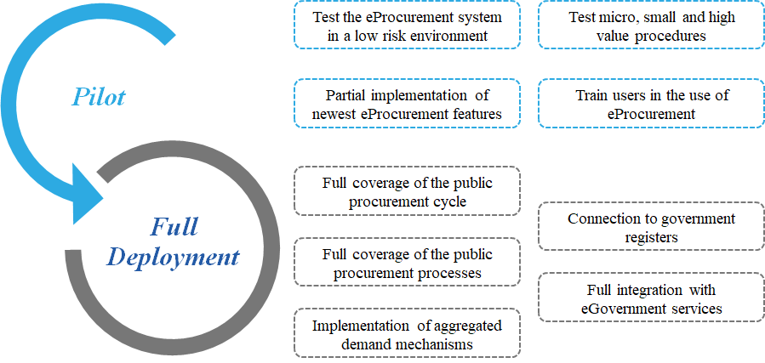Figure 18. Implementation plan Phase I

### Implementation Phase II

Phase II of the eProcurement implementation involves the following developments:

* Implement tools to manage additional public procurement methods, such as Framework Agreements, Dynamic Purchasing Systems or eCatalogues.
* Evolve to a more comprehensive concept connected to other government systems, such as budget management or treasury systems.
* Develop new functionalities and update the existing ones. The functionalities introduced in the first phase shall be upgraded in order to increase their capabilities or adapt them to newly identified user requirements.

## Challenges to be addressed

This section describes the main risks that may appear during the implementation of the eProcurement reform. The likelihood[37] of each one occurring and the consequent impact[38] on the eProcurement implementation reform is analysed. Lastly, a mitigation action is proposed to prevent the risks and reduce their impact if they happen.

The challenges identified are based on the Moldovan reform implementation example, the Ukrainian experience, and challenges identified by stakeholders, such as the EBRD[39], in other eProcurement reforms.

Table 9 Challenges of the implementation of an eProcurement system

| **#** | **Challenge** | **Description** | **Likelihood** | **Impact** | **Mitigation action** |
| --- | --- | --- | --- | --- | --- |
| **1** | **Non re-use of available EBRD solutions** | The non-use of the Open Contracting Digital Procurement System as a basis for the eProcurement system development will make the eProcurement reform more costly and would require more time for implementation. | Likely | Very high | * Provide the solutions **free of any charge** for the implementing partner. * Provide **full documentation to the EBRD developed solutions**, as well as access to the source code, so the solution can be assessed in advance. * **Facilitate technical support for the implementation of the EBRD solutions** from experts implementing those solutions in other jurisdictions. |
| **2** | **System sustainability** | Budget issues may prevent the eProcurement operator from having enough income to cover the Central Unit maintenance. | Likely | High | * **Create a business plan that guarantees sustainability**, considering the **real size of the public procurement market to establish realistic and affordable fee rates for economic operators participating in micro, small and high value procurement.** * **Ensure that fees do not distort competition**. Fees cannot be too high, especially for small value contracts, as that may prevent small companies from participating. |
| **3** | **Political instability** | Political support for the eProcurement reform is key to its success. Turbulent politics and continuous change in high-level officials can jeopardise the successful implementation of a system. | Likely | Very high | * **Engage high-level public administration officials** in the public procurement reform, who may remain in their position despite the political changes. * **Include local experts** in the project team with longstanding experience and knowledge in the field. * **Establish increased assistance for stakeholders** to ensure that they are well informed about the reform process. |
| **4** | **Regulations adoption** | The adoption of primary legislation and specific secondary regulation that provides guarantees for the eProcurement reform is key for: 1) implementation of a system aligned with the legislation, 2) spreading the use of eProcurement, 3) sustainability of the system. | Likely | High | * **Bottom-up approach** for public procurement regulation adoption, starting from micro and small value procurement, not strictly regulated by international treaties commitments or the primary public procurement law. * **Close collaboration with regulators**. Identify champions of the reform with capacity to promote legal reforms. * **Reduce the amount of regulations to be passed.** The fewer regulations that need to be passed through formal approval processes, the faster they can be adopted. |
| **5** | **Data integrity** | Security and integrity during the collection and management of data and the eProcurement system is paramount for establishing a high level of trust with the system. | Unlikely | Medium | * **Implement technical mechanisms to protect the data.** The proper mechanisms will be implemented in order to guarantee the integrity of the data and protect it from unauthorised access. * **Follow Open Data principles.** Following Open Data principles, most of the data shall be publicly available and free to use by everyone interested. Under this principle, the minimum data shall be kept secret. Therefore, not much infrastructure is needed to protect it due to its low volume. |
| **6** | **Platform providers availability** | Adapting NEPPs to the Central Unit requires investment, and a minimum of three providers is needed to guarantee competitiveness. The access fee per tender should allow earning a profit with an obligation of three years minimum of operation. | Remote | Very high | * **Involve potential providers in the eProcurement reform process**. Market research should start once the concept reform is approved, and discussion spaces with businesses must be open during the whole process. * **Open competition to international providers**, especially platforms that have already implemented the system in Ukraine or Moldova. * **Engage platforms with the pilot** and limit required investment with free software to connect to Central Unit and dedicated capacity building. * **Involve civil society and international donors** to guarantee the continuity of the project. |

# Next steps for eProcurement reform implementation

In order to implement the eProcurement reform, the following key activities should be undertaken:

* **Conduct an AS-IS analysis** of the current situation and current practice and legislation on public procurement.
* **Prepare a localised Technical Concept reform**. Based on the AS-IS analysis and this concept reform, prepare a localised concept reform.
* **Approve the Technical Concept reform**. Reach an agreement within the implementing government agency(ies) on the strategic points discussed in the present document.
* **Start the acquisition process for the Central Unit**. This process involves the definition of the terms of reference for the Central Unit, and conducting the tendering procedure.
* **Start the accreditation process for NEPPs**. Initial talks with interested parties should start at the beginning of the project. The goal should be to have at least three working platforms before starting the pilot.
* **Revise the public procurement law and regulations in view of adapting them** to electronic procurement requirements, as well as to EUPD 2014 and WTO GPA requirements.
* **Start the pilot.** The eProcurement system will start a pilot on micro-procedures and a pilot on EU/GPA above-threshold procedures.

# Annexes

## Annex I - Functionalities description

The functionalities discussed in the coverage section are presented and defined below:

Table 10 Functionalities description

| **Functionality** | **Description** |
| --- | --- |
| **BPE** | The **Business Processing Engine (BPE)** is the logical layer responsible for identifying an event, and then selecting and executing the appropriate reaction. It can also trigger several assertions. Processing involves tracking and analysing streams of data from events to support better insight and decision making. The rest of the modules are components that ‘work’ as a demand of the BPE. |
| **Web portal** | **Single government portal** providing an open access to the eProcurement System and publishing all relevant information on public procurement for all public procurement process stakeholders, including civil society. |
| **eBudget** | **eBudget** allows the online definition and preparation of expenditure items, funding sources, periods of budgeting and budgets in structured form. |
| **ePlanning** | **ePlanning** allows the **scheduling** of public procurement procedures from **yearly and individual** perspectives. Procurement planning involves adopting a coherent approach to the acquisition of work, goods, or services, the definition of the procurement process, the engagement of stakeholders, and the governance of the project. |
| **eAccess** | eAccess allows user administrations on the CDU side to **set the workflow, validation rules, data structure** and other features of the tender information to be published by the NEPPs. |
| **eNotices** | On the Central Database Unit, the eNotices module will support the **dispatch of procurement notices** for online publication and publication in the Official Journal of the European Union (OJEU), best known by the name of the platform publishing the information, Tender Electronic Daily (TED), via the eSender tool. |
| **eClarification** | The eClarification module allows the economic operators to communicate with the contracting authority and **request clarifications** both during the tendering process and at the end of the tendering period. |
| **eSubmission** | This module must allow economic operators to **prepare their bids in a structured and secured way** in response to a contract notice and to submit their bids electronically, using the interactive submission workflows of the eProcurement System. |
| **eQualification** | This module handles the **legal, economic and financial qualification** of the tenderer selected for award of public contract through ESPD. |
| **eAuction** | eAuction must facilitate the configuration, coding of bidders and management of **auctions** held electronically. |
| **eEvaluation** | This module provides tools to support the **evaluation** of tenders by the contracting authorities. |
| **eAwarding** | The module allows for **awarding the contract and preparation of the contract,** as well as notifying the stakeholders involved. |
| **eContract management** | eContract Management is designed to **monitor and manage a contract** and its requests and changes once it has been signed. This includes amendments and extensions, deliverables, and performance reports. |
| **eMonitoring** | This module must allow **data extraction** as well as access to reports and **analysis** of the data stored in the database. This functionality can be provided by the available EBRD open data analytics solutions. |
| **Document management** | This module is responsible for generating, registering and archiving the decrypted human readable version of the **tender documents**. |
| **eInvoicing** | This module encompasses the process of **issuing, transmitting, and receiving invoices** in a structured electronic format, which allows for their automatic and electronic processing. |
| **eRegistration** | This module allows the **creation of users** and their registration in the system, creating a unique ID for each user and user record. |
| **eAuthentication** | This module is responsible for **identifying the users** and obtaining and setting their authorisation to perform specific actions within the system. |
| **eNotification** | This module **enables communication** among system users and notifications on new events relating to the public procurement process. |
| **Cabinets for single users** | Cabinets are **dedicated work areas for single users** (such as the Remedies Body and/or central purchasing bodies) located on the Public Portal within the system, where they can execute their specific functions and access the information they need within the system. |
| **eComplaint** | This module enables the **registration, examination and settlement of complaints** using electronic processes within the Open Contracting Digital Procurement System. |

## Annex II - Case study: Moldova MTender implementation

This annex outlines a successful case study in which the Open Contracting Digital Procurement System was implemented by EBRD, as well as t key findings from that experience.

The Ministry of Finance of Moldova developed the ‘Strategy for Public Procurement Sector 2016-2020’ to modernise public procurement in Moldova in accordance with the Association Agreement between the European Union and the Republic of Moldova and the Agreement on Government Procurement of the World Trade Organization (the GPA) that Moldova joined in September 2015. To support the implementation of the Strategy, the European Bank for Reconstruction and Development (EBRD) advocated a concept of highly transparent digital public procurement to ensure implementation of best practice procurement policy and governance standards.

To enable the introduction of ‘end-to-end’ electronic public procurement in Moldova as envisaged in the ‘2016 Strategy for Public Procurement’, a phased implementation of eProcurement was considered. A pilot of the OCDS Networking Multi-Platform Digital Procurement (MTender) was developed for the Ministry of Finance of Moldova by the EBRD technical cooperation project.

On 30 November 2016, the Ministry of Finance, eGovernment Centre, Public Procurement Agency, business associations, NGOs, and IT companies signed a memorandum to work collaboratively to develop a new digital procurement service for Moldova (MTender Memorandum). Work on the pilot started immediately and in April 2017, a pilot of MTender – a partnership between the Ministry of Finance of Moldova, Moldovan commercial electronic platforms and civil society watchdog organisations – was launched. Overall, six local Moldovan e-commerce operators signed the MTender Memorandum, out of which three developed electronic procurement services and are operational, providing electronic bidding and online contracting services to public sector clients as well as commercial buyers.

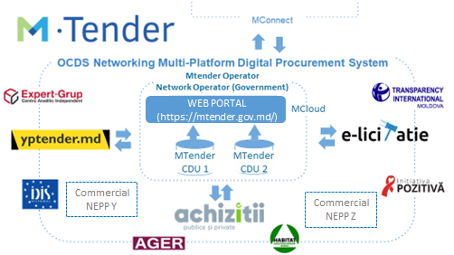

Figure 1. Model of MTender Networking Digital Procurement System (pilot partners as of September 2019)

The pilot project prepared and launched an innovative OCDS multi-platform networking digital system, using OCDS prototypes built with open source technologies and aligned with Open Data for Government Standard and Open Contracting Data Standard to deliver the ‘end-to-end’ digital public procurement, from planning public spending to payment for public contracts.

The MTender System is a modern cloud-based system installed in the MCloud – the government cloud of Moldova – and is interoperable with e-government services that are available for integration (MSign, MPass, MLog, eFactura and MConnect).

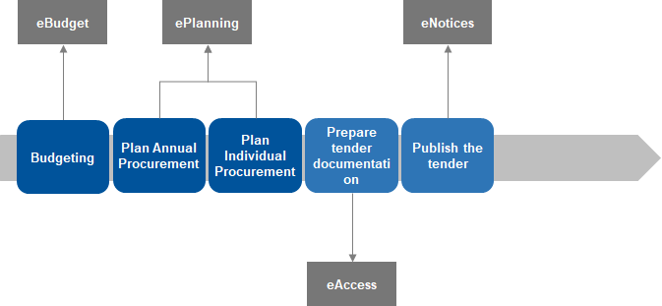

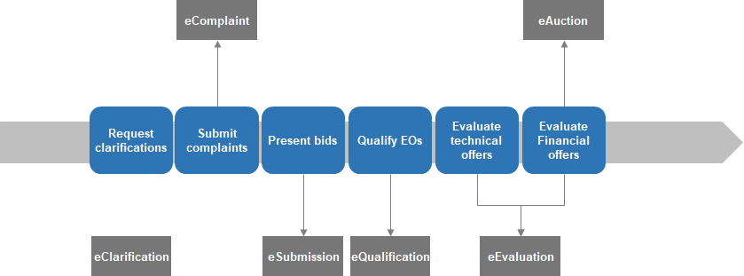

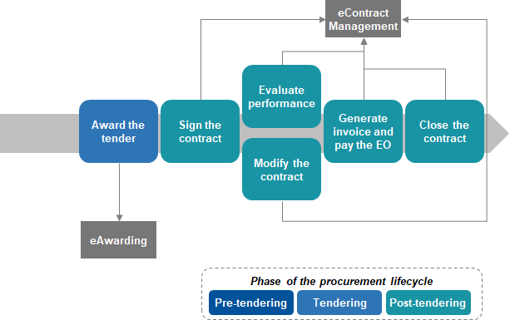

Figure 2. MTender coverage of the public procurement lifecycle

Use of open source technologies for the central database unit and web portal of MTender enabled the pilot to be launched quickly (within four months), reduced the initial cost of the system by an estimated 30%, and decreased operational costs for the Government of Moldova – there are no annual licence fees to be paid for the MTender central database unit and web portal applications.

The lower cost for government of the MTender System was also possible because of cost-sharing with collaborating commercial platform operators and a sustainability scheme to self-fund MTender operation with fees paid by commercial users of the digital service.

Normally, to introduce a new e-government service, the government would be required to fund the acquisition cost of the new ICT system and cover annual operational costs of maintenance and development. Thanks to the collaborative delivery of the digital service agreed with commercial platforms in the MTender Memorandum, the government is only responsible for part of the cost of MTender – development and operation of the web portal and central database unit. Commercial partners committed to cover the cost of interconnection and application development, to provide digital procurement services to contracting authorities and economic operators in exchange for charging subscription fees from commercial users of MTender (public sector users do not pay any user fees and subscription fees for commercial users are approved by the Ministry of Finance of Moldova).

Implementation of the Open Contracting Data Standard for collecting data in real time and publishing online machine-readable data from digital public procurement conducted on the MTender results in ever-increasing transparency of public procurement. Adherence to the Open Contracting Data Standard as a building principle of data exchange in MTender delivers quality, reliable and fully accountable open data, directly and automatically from each public procurement procedure that can be trusted for re-use by government, business and civil society alike and facilitates interoperability and integration of MTender with other e-government services and the public finance management system.

The project was developed as follows:

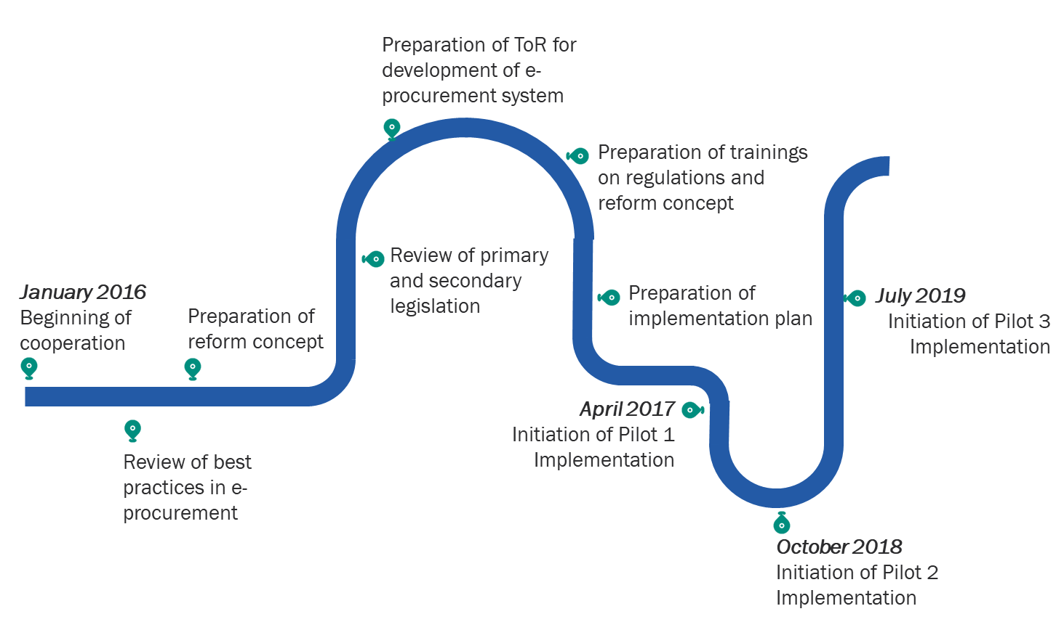

Figure 3. MTender project milestones

The pilots built on each other in order to create a full eProcurement system that was adapted to Moldova’s reality and was sustainable in the long term. The characteristics of each pilot are described below.

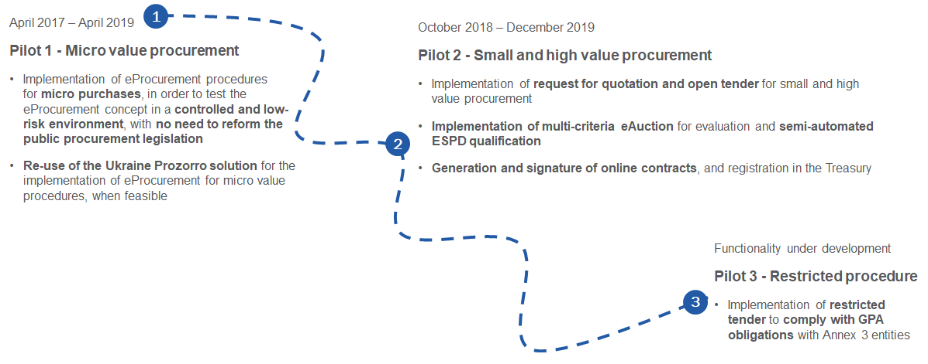

In parallel to the development and piloting process of MTender, the Regulatory framework for MTender eProcurement functionalities has also been changed and major legislative changes are still pending in order to achieve a law that fully embraces international standards and digital procurement. The legislative reform was organised in two parts: first, ministerial orders and secondary legislation was used to allow MTender to advance without a lengthy legislative change process. In parallel, the primary legislation (Public Procurement Law 313 or PPL313) was reviewed, and changes proposed in order to advance on the regulatory framework. The following graph summarises the legislative changes that were needed:

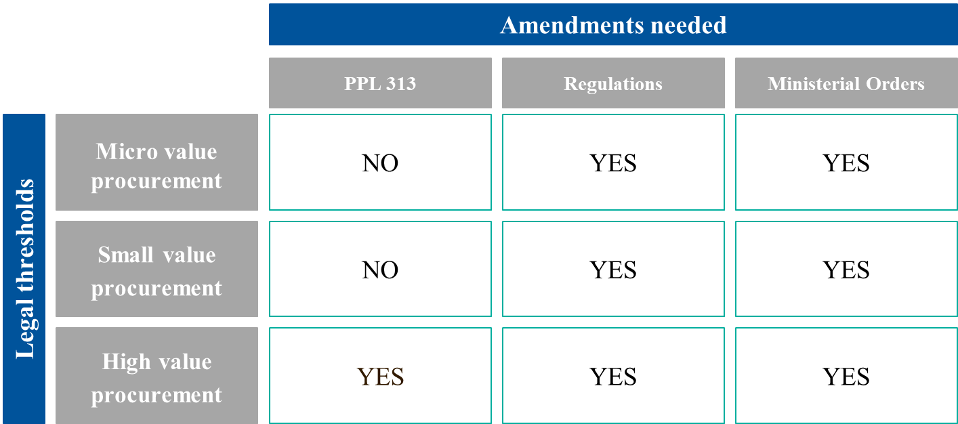

Figure 4. MTender project legal amendments needed

Despite obstacles resulting from insufficient budget, the lack of secondary legislation required to progress with the MTender development, and teething pains of piloting innovation, the achievements of the MTender pilots have so far been impressive. Within 11 months since the launch of Phase 2 of the MTender pilot (17 October 2018 – 17 September 2019), the following results have been achieved:

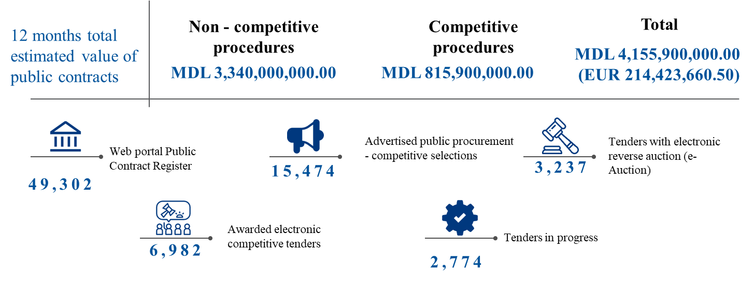

Figure 5. MTender key results (September 2019)

In terms of participation, the figures also look promising, especially compared to the situation in 2017 when the SIA RSAP system for electronic procurement was in place:

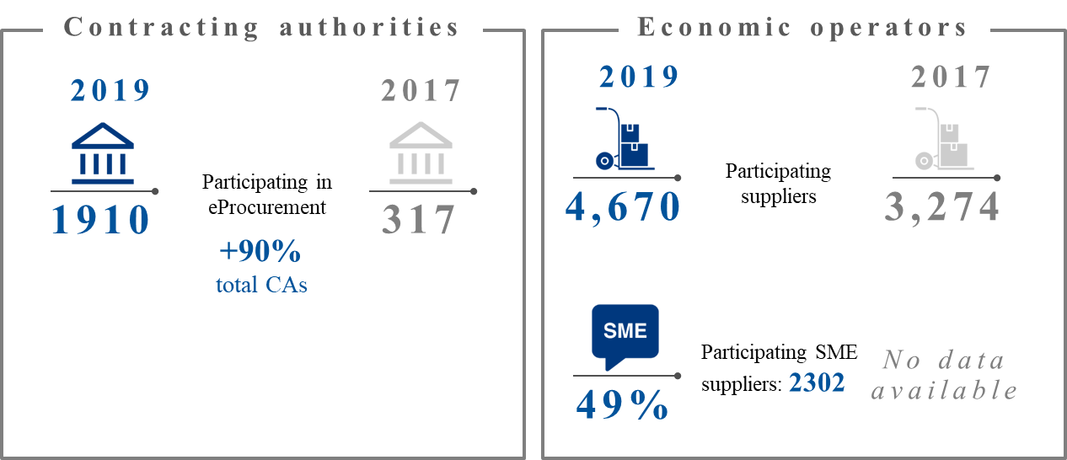

Figure 6. MTender participation figures

Finally, it is also worth mentioning the price tag of the project, which gives a good idea on what to expect from a similar project and demonstrates how, with minimum investment, great results can be achieved. At this point, the pilot system set up in Moldova has cost around EUR 700,000. Fully fledged digital procurement is estimated to reach EUR 1,500,000.

Overall, the pilot of the MTender System radically transformed public procurement in Moldova and moved it from Step 2 to Step 4 of the digital transformation process, with an excellent value for money:

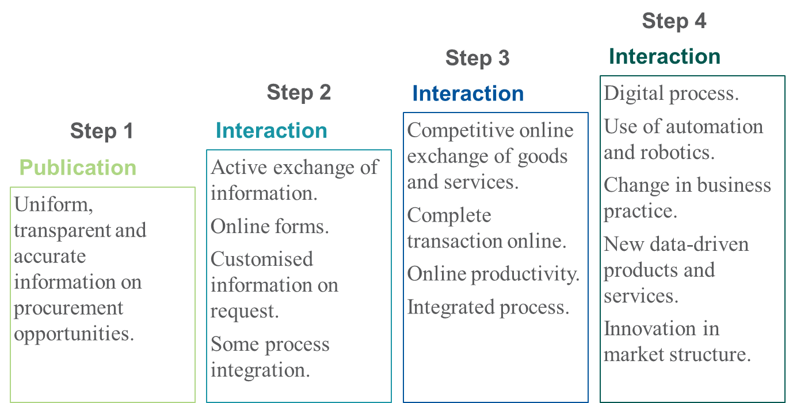

Figure 7. MTender public procurement stage

**Key findings from previous experiences**

The following key points summarise the main lessons learnt from the EBRD experience[40]. They are organised according to the three areas of decision: legal, business and technology.

Table 4 key findings from previous experience

|  |  |
| --- | --- |
| **LEGAL** | * Include all mandatory default procedures as defined by the EUPD 2014[41] * Establish mandatory use of electronic procedures * Guarantee that all contracting authorities apply the same rules and follow a uniform business process by design * Adjust the institutional structure to cope with the eProcurement reform |
| **BUSINESS** | * Involve political decision-makers * Involve multidisciplinary stakeholders in the procurement process reform * Adapt the eProcurement system to the local public procurement market * Leverage technology to push for change of current practices * Establish strategic procurement centralised in framework agreements that are mandatory for central government and contracting entities, financed from the state budget * Open public procurement data * Plan change management and communication strategy |
| **TECHNOLOGY** | * Implement a rational scope of functionalities in a gradual way * Interoperability matters and should be considered early in the process * Do not request an electronic signature for tender participation * Introduce a qualified electronic signature in online contract signing |

1. For example, it is mentioned in the “Study on up-take of emerging technologies in public procurement” by the Directorate General for Internal Market, Industry, Entrepreneurship and SMEs of the European Commission (<https://joinup.ec.europa.eu/sites/default/files/news/2020-06/D.01.06_Final_report_v3.00.pdf>)
2. https://uncitral.un.org/en/texts/procurement/modellaw/public_procurement
3. EBRD (2015). “Are you ready for eProcurement? Guide to electronic procurement reform”. Access at: <https://www.ebrd.com/documents/legal-reform/guide-to-eprocurement-reform.pdf>
4. TED (Tenders Electronic Daily) is the online version of the 'Supplement to the Official Journal'. Access at: <https://ted.europa.eu/TED/main/HomePage.do>
5. <https://standard.open-contracting.org/>
6. DG MARKT (2013). e-Procurement Golden Book of Good Practice. Access at:

   <https://ec.europa.eu/archives/dgs/internal_market/studies/docs/e-procurement-golden-book-of-good-practice_en.pdf>
7. e-TEG recommendations are accessible at:

   <http://ec.europa.eu/DocsRoom/documents/18026/attachments/1/translations/en/renditions/pdf>
8. This is possible through the web portal.
9. This is possible because contract notices include access to tender documentation.
10. Through the library of technical specifications.
11. EBRD (2015), “Are you ready for eProcurement? Guide to electronic procurement reform”. Access at: <https://www.ebrd.com/documents/legal-reform/guide-to-eprocurement-reform.pdf>
12. Examples of successful deployments of such projects by the EBRD can be found in Kyrgyz Republic, where a monitoring and reporting tool has been deployed based on OCDS that informs decisions by the public procurement department. Another relevant example is Kazakhstan, where already existing data has been structured according to OCDS and provided through analytical tools to facilitate decision-making and foster transparency.
13. The final agreement with the platforms, including their SLAs, will determine the final costs for the government. Therefore, it may happen that there is an agreement for training costs to be partially covered by the government.
14. The logic of the fee structure is discussed in section 4.5.1 and can be adapted to the reality of each country and procurement system.
15. EBRD (2015), “Are you ready for eProcurement? Guide to electronic procurement reform”. Access at: <https://www.ebrd.com/documents/legal-reform/guide-to-eprocurement-reform.pdf>
16. eCommunication: All electronic communication from tenderers should be accepted, without any additional formalities or requiring a visit to the contracting entity in person.
17. eSubmission: The submission of bids by economic operators is done electronically.
18. eAccess: All information relevant for economic operators and other stakeholders about public procurement procedures is accessible through electronic forms.
19. eRecords: Contracting entities should be required to record procurement decisions in real time and ensure that selected procurement records are readily accessible to the public online, preferably free of charge.
20. The open source code can be consulted here: <https://github.com/MTendereProcurementSystem/MTender/wiki> and is licensed under the GNU Affero General Public License v3.0
21. EUPD 2014 requires the mandatory implementation of eRegistration, eAuthentication, eNotification, eAccess, eSubmission, eInvoicing, and ePayments.
22. Information on eSender mechanisms: <https://simap.ted.europa.eu/web/simap/sending-electronic-notices>
23. Open source concept: <https://opensource.org/docs/osd>
24. The complete set of tools developed are being collected and prepared for publishing in the coming months.
25. Open Contracting Digital Procurement System GitHub: https://github.com/EBRD-Digital-Transformation-MTender/MTender/wiki

   
26. Some tools made available for reuse by OCP are accessible at: <https://www.open-contracting.org/data-standard/tools/>
27. In the case of Ukraine, more than 20 platforms have passed the accreditation process. In the case of Moldova, only in the pilot stage, three different platforms were accredited.
28. Open Contracting Data Standards are constantly reviewed and published here: <https://www.open-contracting.org/data-standard/> .
29. As an illustration of such mechanisms, the DoZorro portal (<https://dozorro.org/> ) can be consulted, through which Ukraine’s public procurement is monitored by NGOs and anonymous citizens.
30. <http://standard.open-contracting.org/latest/en/>
31. https://github.com/EBRD-Digital-Transformation-MTender/MTender/wiki/MTender-disruptive-technologies
32. In the case of Ukraine, it must have at least a 1 GB/s connection between Central Unit and NEPPs’ back-end in order to meet the SLA for replication time. Ukraine also encourages broadband connections between end-users and their Internet Service Provider in order to guarantee proper working of the system, especially when uploading large tender documents and for quick reactivity during the auctions.
33. The fees are estimated based on the ones implemented in Ukraine in the implementation of the Open Contracting Digital Procurement System, ProZorro. The fee model for Moldova has not yet been approved by the Government of the Republic of Moldova.
34. The total amount for the Moldova pilot can be found in section 3.1. of this document. For the case of Ukraine, the approximate costs were:

    Initial investment for software development (Central Unit): 215.790 EUR;

    Operations (hosting, operations, admin, client support, etc.): 76.608 EUR;

    Marketing: 11.151 EUR.

    The total cost of development and implementation was: 303.549 EUR.
35. EBRD (2015). “Are you ready for eProcurement? Guide to electronic procurement reform”. Access at: <https://www.ebrd.com/documents/legal-reform/guide-to-eprocurement-reform.pdf>
36. <https://ebrd.huddle.net/workspace/39084702/files/#/81272152>
37. Likelihood: A) remote; B) unlikely; C) likely; D) highly likely; and E) near certainty
38. Impact: a) very low; b) low impact; c) medium impact; d) high impact; and e) very high impact
39. EBRD (2015). “Are you ready for eProcurement? Guide to electronic procurement reform”. Access at: <https://www.ebrd.com/documents/legal-reform/guide-to-eprocurement-reform.pdf>
40. Latest projects on public procurement carried out by EBRD can be consulted here:

    <https://www.ebrd.com/cs/Satellite?c=Content&cid=1395281257031&pagename=EBRD%2FContent%2FContentLayout>
41. The EUPD 2014 can be consulted here: <https://eur-lex.europa.eu/legal-content/EN/TXT/?uri=CELEX%3A32014L0024>